Navigating the clinical document viewer tree: a quick reference guide

Introduction

Purpose of the guide
This guide explains how to navigate around the clinical document viewer.
The clinical document viewer tree is accessible alongside the person summary screen. It organises documents within a person's record into folders, consolidating information from multiple sources into a unified structure.

Target audience
Anyone who uses the Shared Care Record.

Prerequisites and requirements
Access to Shared Care Record with an individuals’ record open.
Please note that the record shown is a test patient and does not contain any personal identifiable information.

Step-by-step instructions

Information in the clinical document viewer tree is arranged by organisation first, and then type of information. This is accessible from on the left-hand side of the screen.
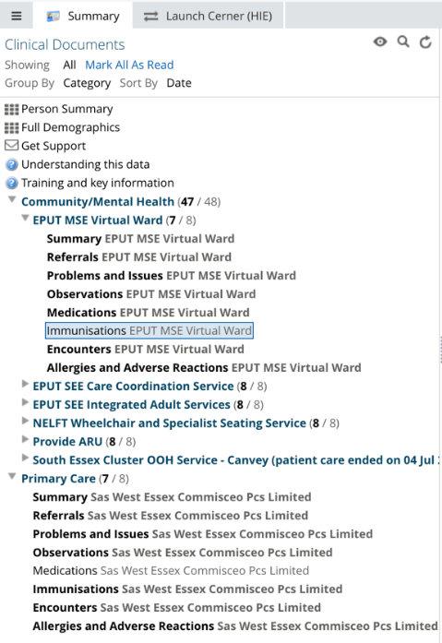

When you expand the organisation folders, you will be presented with subfolders which include summary, referrals, problems and issues, observations, medications, immunisations, and encounters.
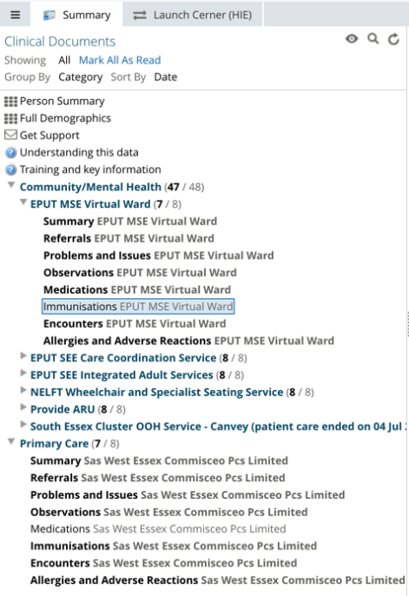

Hovering your mouse over a subfolder will present further information, including category, subcategory, service, author, care setting, data source and organisation.
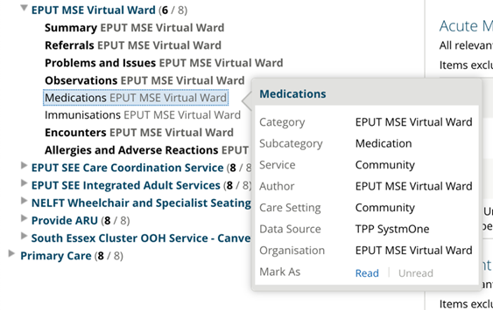

Demographic mismatch alert

If the demographic information provided by one IT system that does not match what is provided by another, a demographic mismatch alert will appear at the top of every subfolder page.
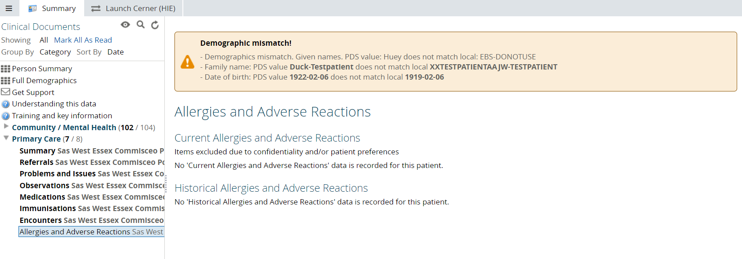

If you encounter this alert, please follow your standard procedures to verify the information with the person you are caring for, ensuring that the correct data is used throughout their care journey. You may want to update inaccurate data within your own IT system.

Summary subfolder within clinical document viewer tree

When you select summary subfolder, it will display the following information.
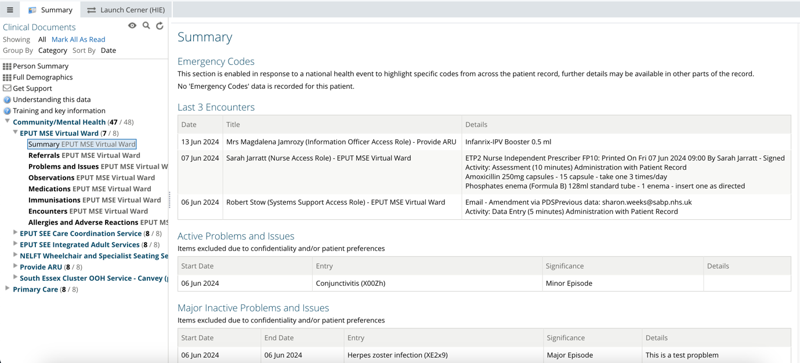

When you select referral subfolder, it will display the following information.
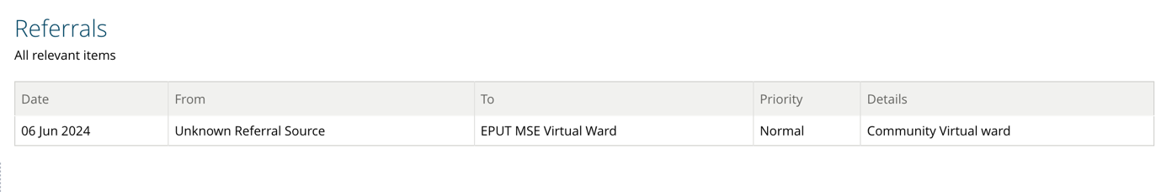

When you select problems and issues subfolder, it will display the following information.
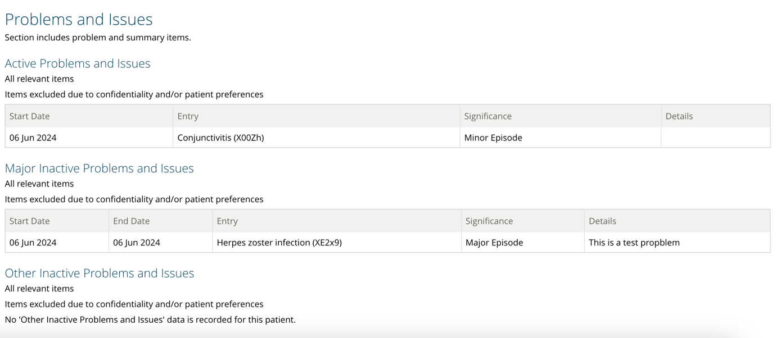

When you select observations subfolder, it will display the following information.
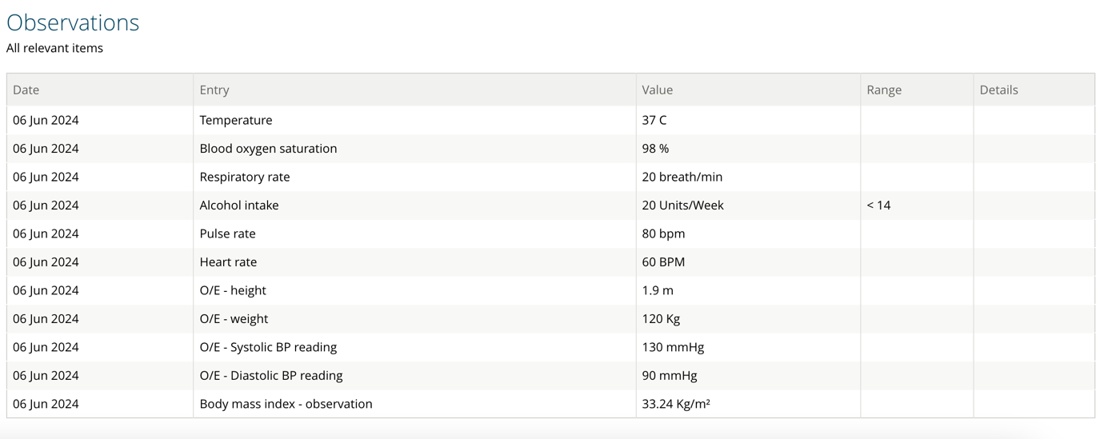

When you select medications subfolder, it will display the following information.
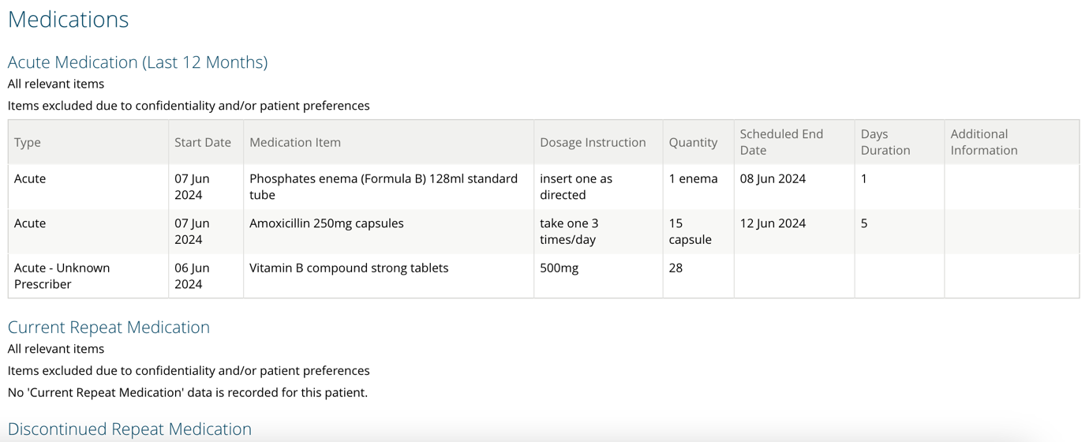

When you select immunisations subfolder, it will display the following information.
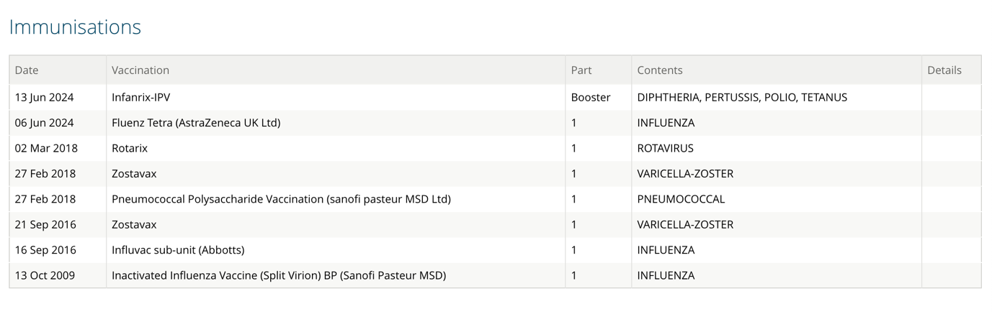

When you select encounters subfolder, it will display the following information.
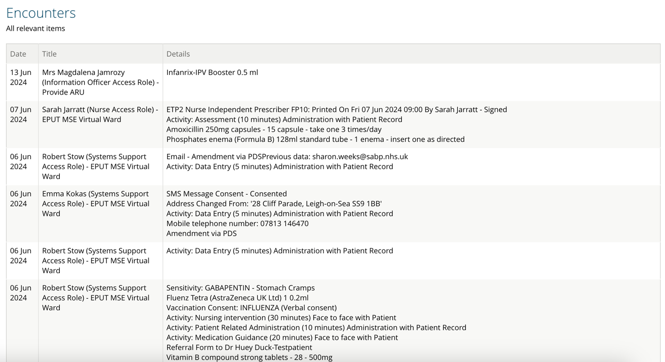

Locating data from EPUT services
EPUT provides acute mental health services and community health services. Data from these services comes from different IT systems and is organised into different sections within the clinical document viewer tree. Users will find data from various EPUT services located in separate folders:

EPUT community health data can be found under the Community/Mental Health section.
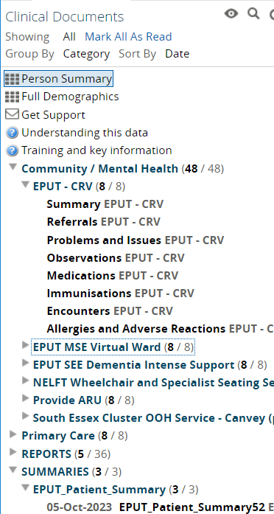

EPUT acute mental health data can be located under the Assessments, Care Plans, Correspondence and Legal Document sections.
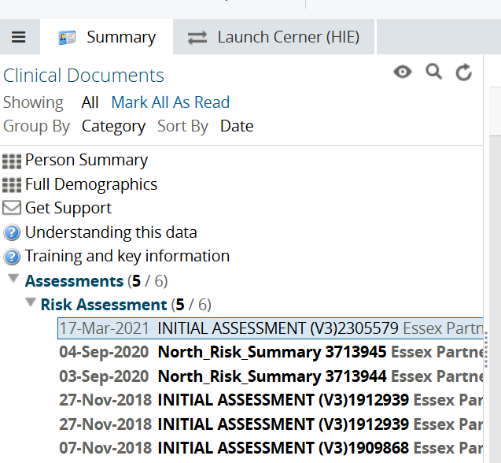
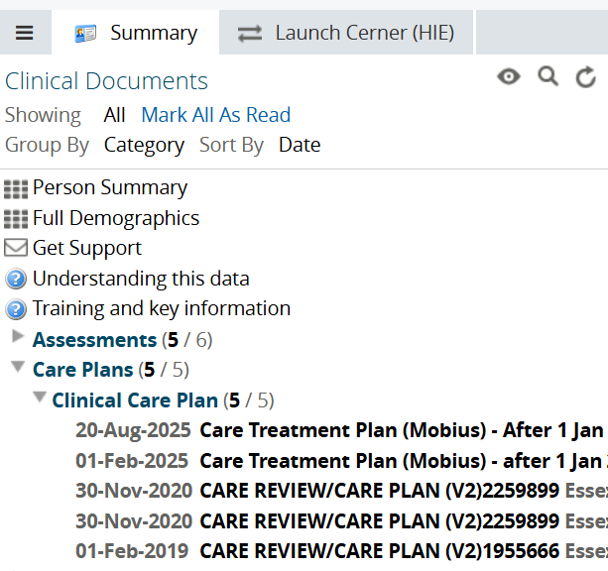
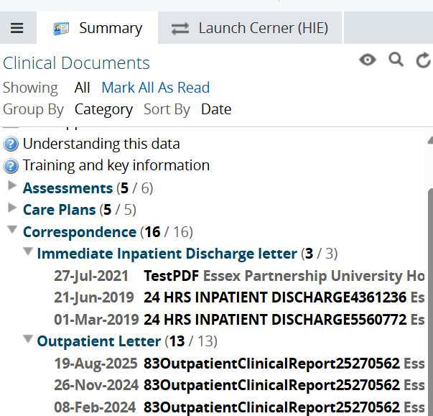
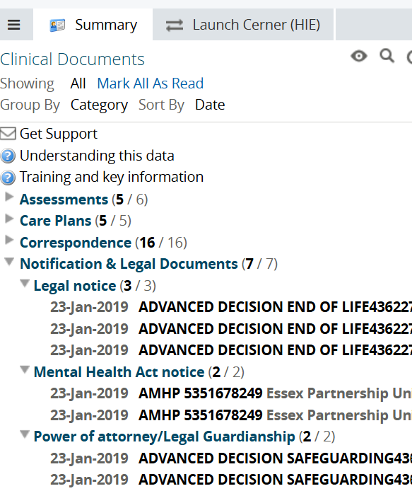

Locating MSEFT discharge summaries letters

To view discharge summaries and letters from Mid and South Essex Foundation Trust (MSEFT), navigate to the correspondence section within the clinical document viewer.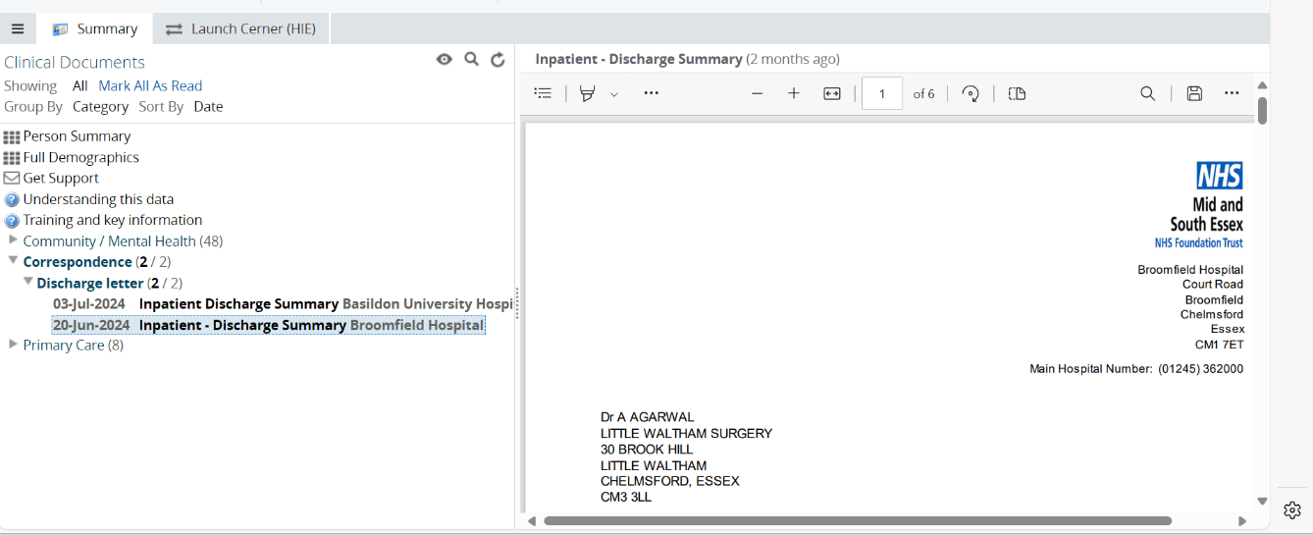

Error message when accessing primary care data

Primary care data is shared via GP Connect. In the unlikely event that a person is not registered with a GP practice that has enabled GP Connect sharing, the following message may be displayed:
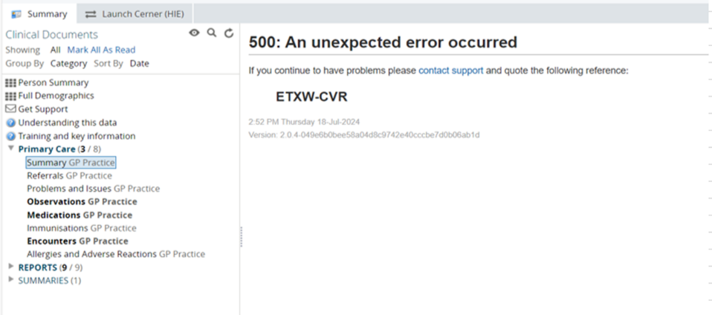
This message typically indicates one of the following:
- The patient is registered with a GP practice outside of Mid and South Essex (MSE), Suffolk and North East Essex (SNEE), or Hertfordshire and West Essex (HWE), and the Shared Care Record cannot retrieve GP Connect data.
- The patient has moved to a new area and is no longer registered with a GP practice that has enabled GP Connect sharing.

In these cases, GP data will not be available, and the error message will appear in the summary section under primary care.

Additional resources
- Further information: https://midandsouthessex.ics.nhs.uk/sharedcarerecord
- Contact information for feedback: mse.sharedcarerecord@nhs.net

