Logging in, person search and setting the home page: a quick reference guide

Introduction

Purpose of the guide
This guide explains how to access the Shared Care Record using a user ID and password to log in via a web browser. It also explains how to search for individual’s records.

Target audience
This guide is only relevant to users who access the Shared Care Record with login details. Unless you have been contacted by your organisation about this, please refer to the single sign on training materials here.

Prerequisites and requirements
User credentials are to be created prior to accessing the Shared Care Record.
Please note that the record shown is a test patient and does not contain any personal identifiable information.

Logging in directly: step-by-step instructions

Navigate to: https://mse.orionhealthcloud.com/concerto/Concerto.htm in your preferred internet browser.
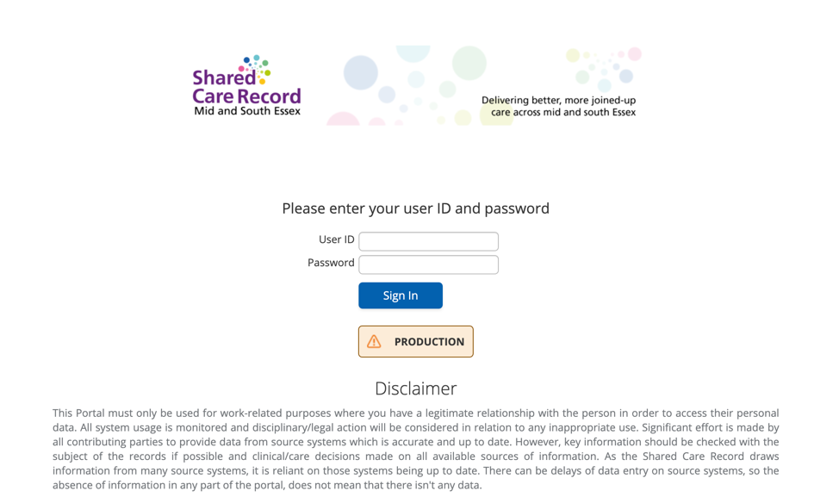

Before you enter your log in details, please ensure you read any disclaimer messages and other important notices that may appear on the login page.
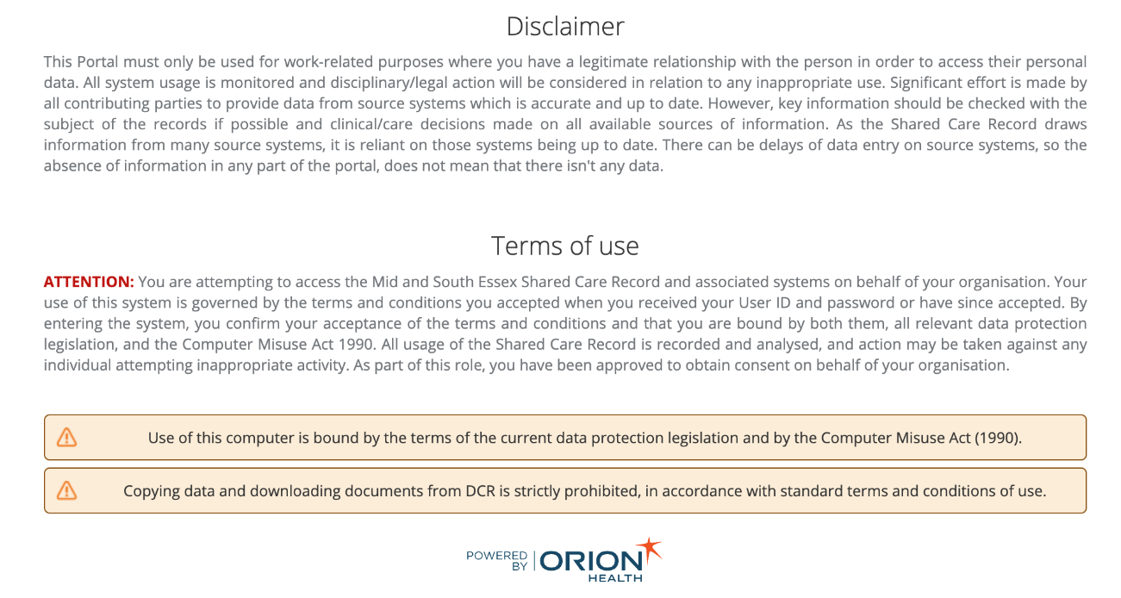

Enter username and password and click sign in.
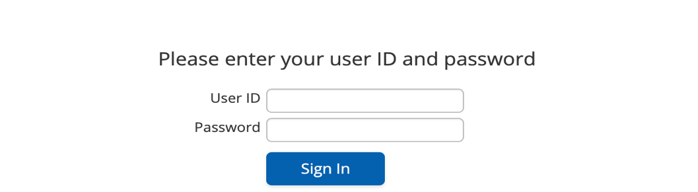

Select the organisation from the drop-down list and click sign in.
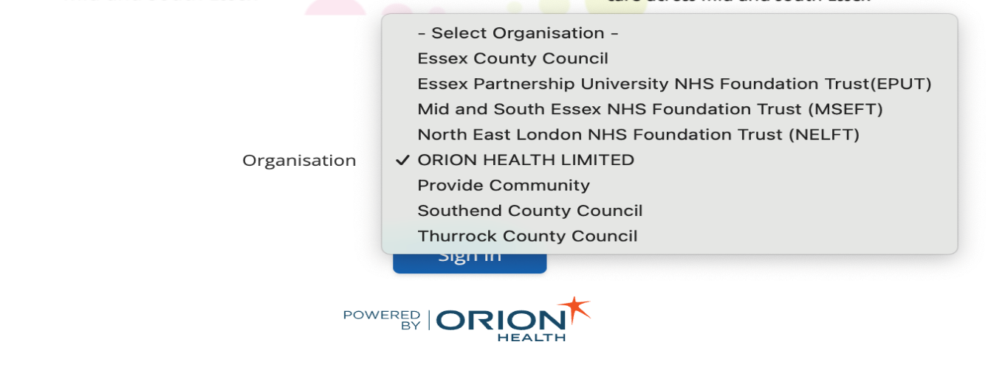

When you log into the Shared Care Record for the first time, you will be taken to a disclaimer page, otherwise you will be taken to your landing page.
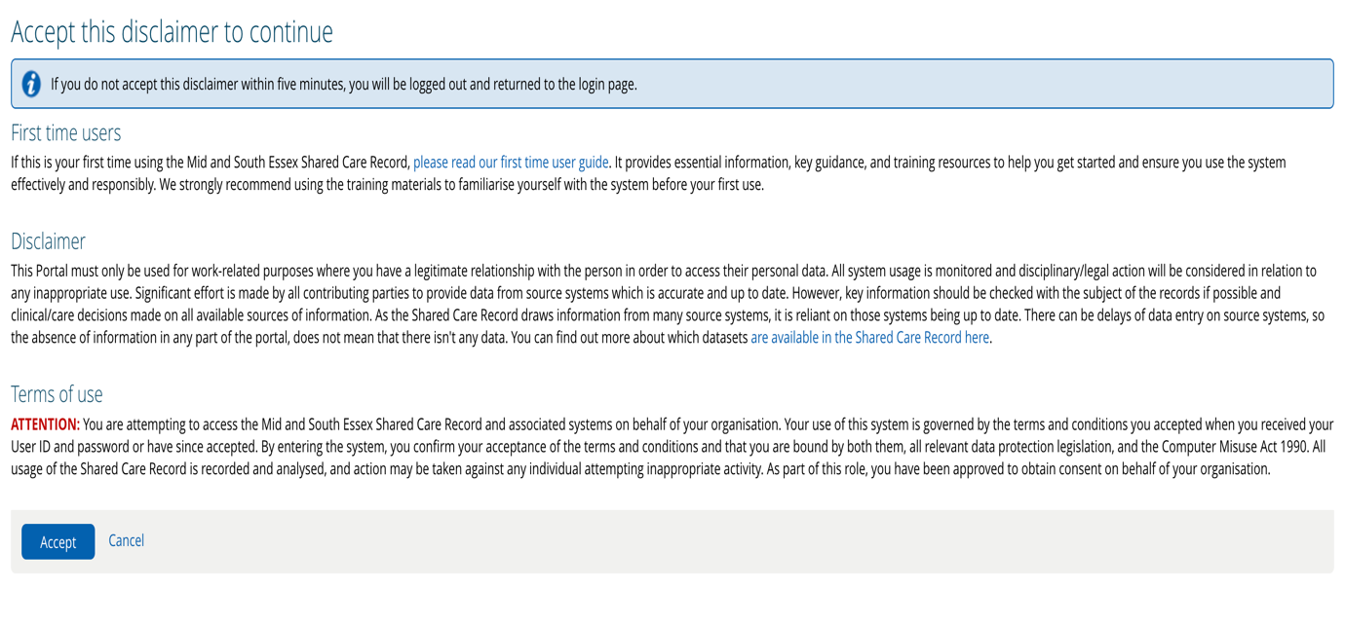

There are links available within the disclaimer message. These links take you to the MSE ICS website where you can review essential information.
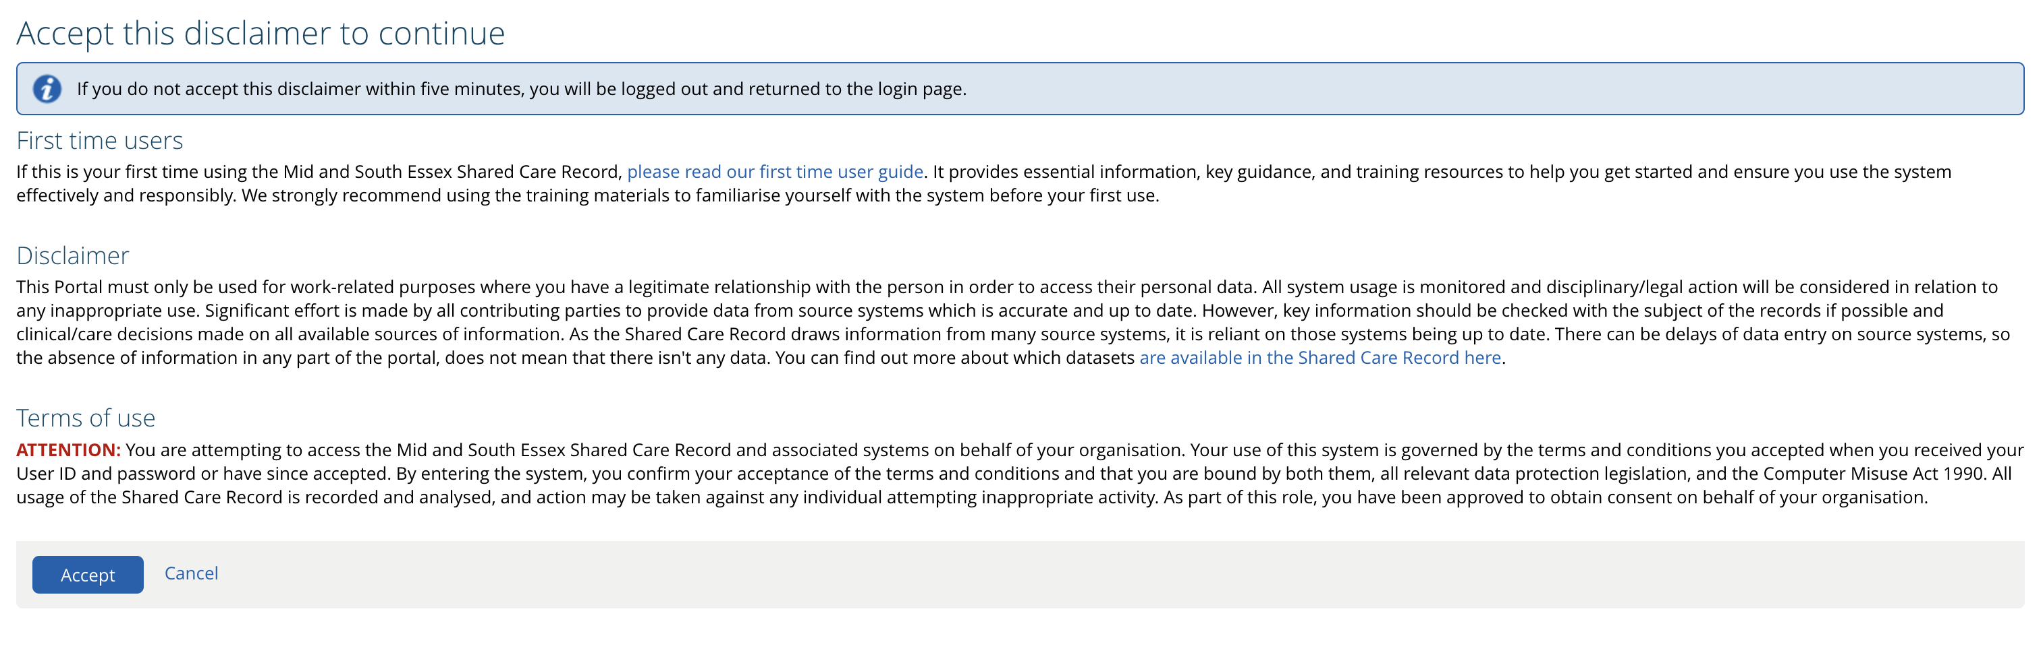

When you log into the Shared Care Record, you will be taken to the person search screen.

Person search: step-by-step instructions

The NHS Number and other identifier fields are unique search fields and will return an exact match which is the recommended way to search for an individual’s record. You can only search using one of these fields at a time.
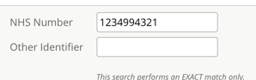
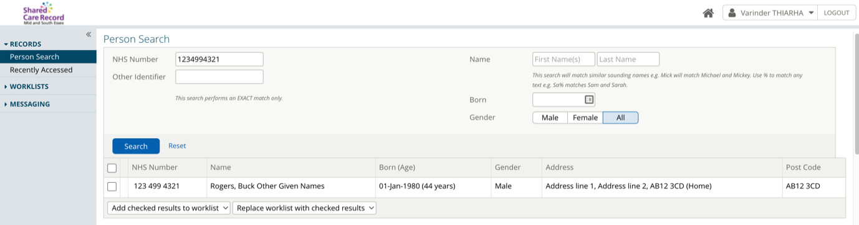

It is also possible to search for a person using the following search criteria: first name, last name, date of birth and gender. Please note, you cannot search this criteria and a unique identifiers and the same time.
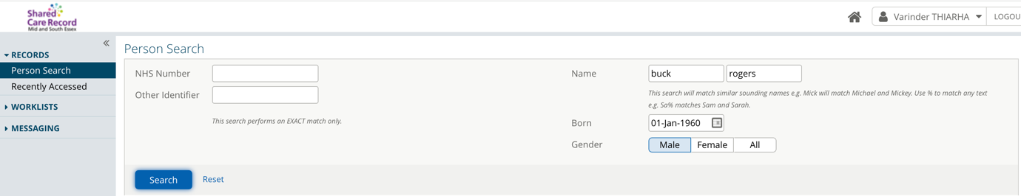

If you search using the person’s name and date of birth, it may return multiple matches for a person matching these criteria. It is important to check demographic information prior to opening a person’s record.
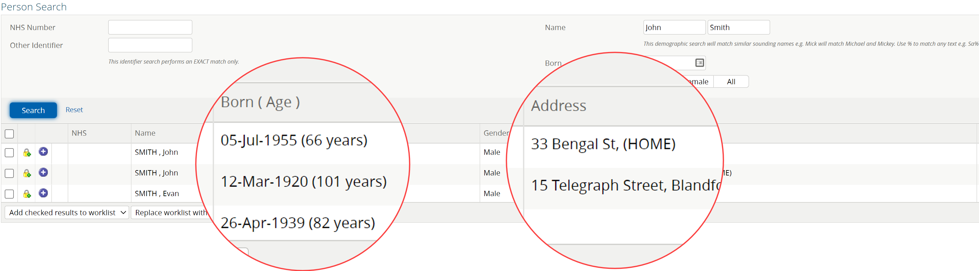

Setting the homepage: step-by-step instructions

You can change your home page by selecting user settings from the top right-hand side of the screen.
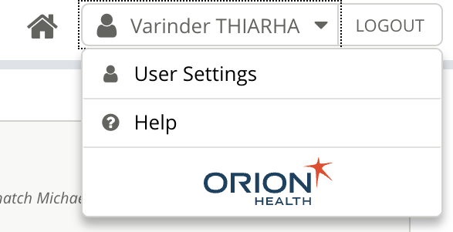

Underneath the username fields, select the start screen drop down menu.
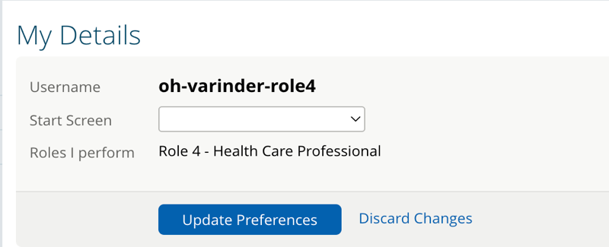

Select the default start screen you want to see when you log in from the drop-down list.
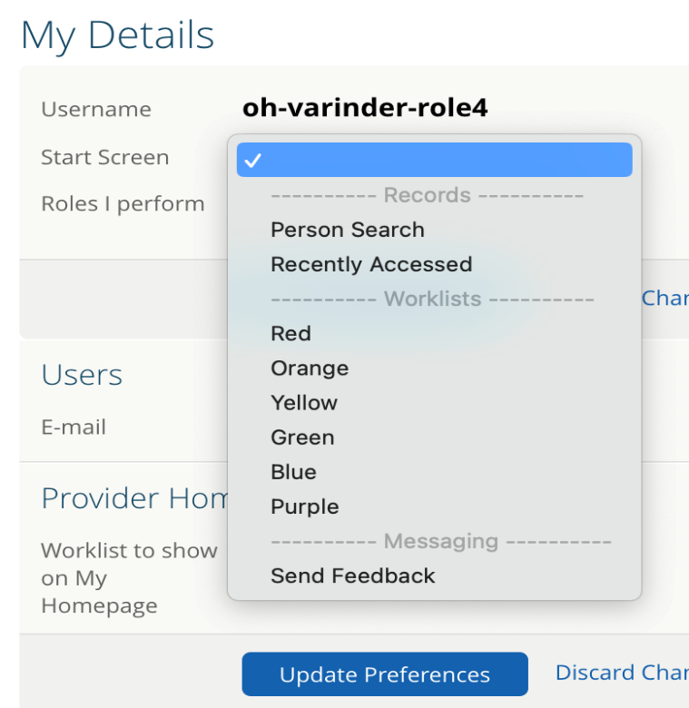

Select update preferences for your change to take effect.
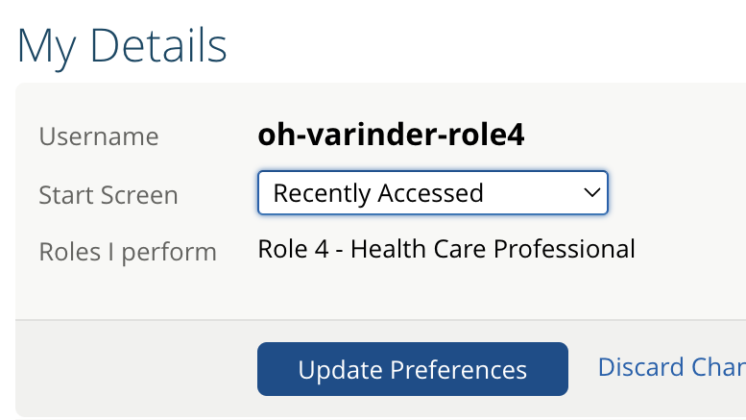

Selecting the homepage icon will take you to the start screen you have selected.


The recently accessed screen will be displayed as default homepage.
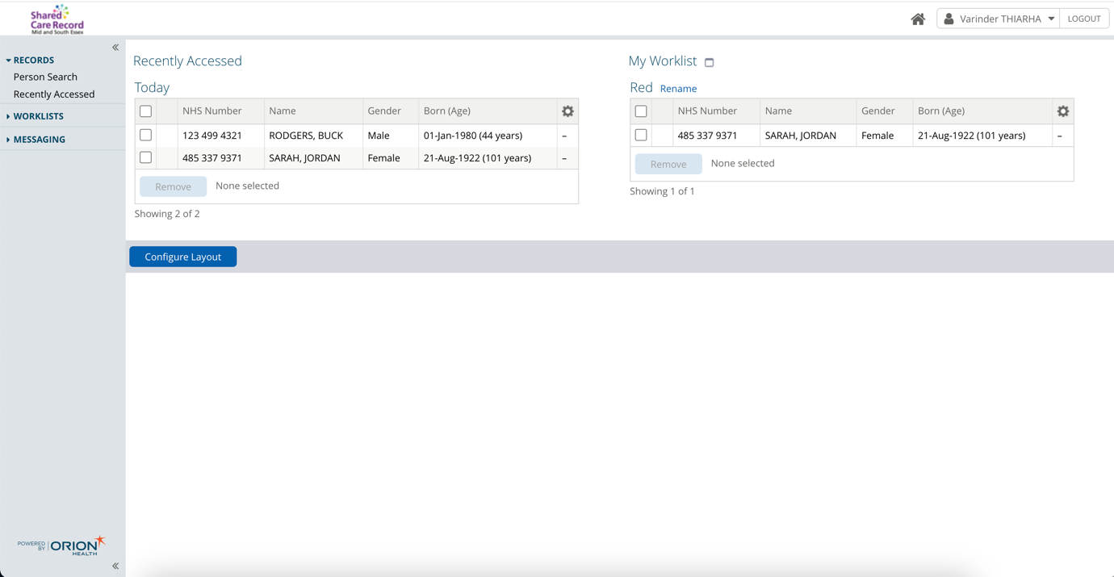

Additional resources
- Further information: https://midandsouthessex.ics.nhs.uk/sharedcarerecord
- Contact information for feedback: mse.sharedcarerecord@nhs.net

