Get support: a quick reference guide

Introduction

Purpose of the guide

This guide explains show users how to access the get support screen to view the support routes.

Target audience
Anyone who uses the Shared Care Record.

Prerequisites and requirements
Access to Shared Care Record with an individual’s record open.
Please note that the record shown is a test patient and does not contain any personal identifiable information.

Step-by-step instructions

Select the get support from the clinical document viewer tree within the person summary tab.


This will show the following support information:
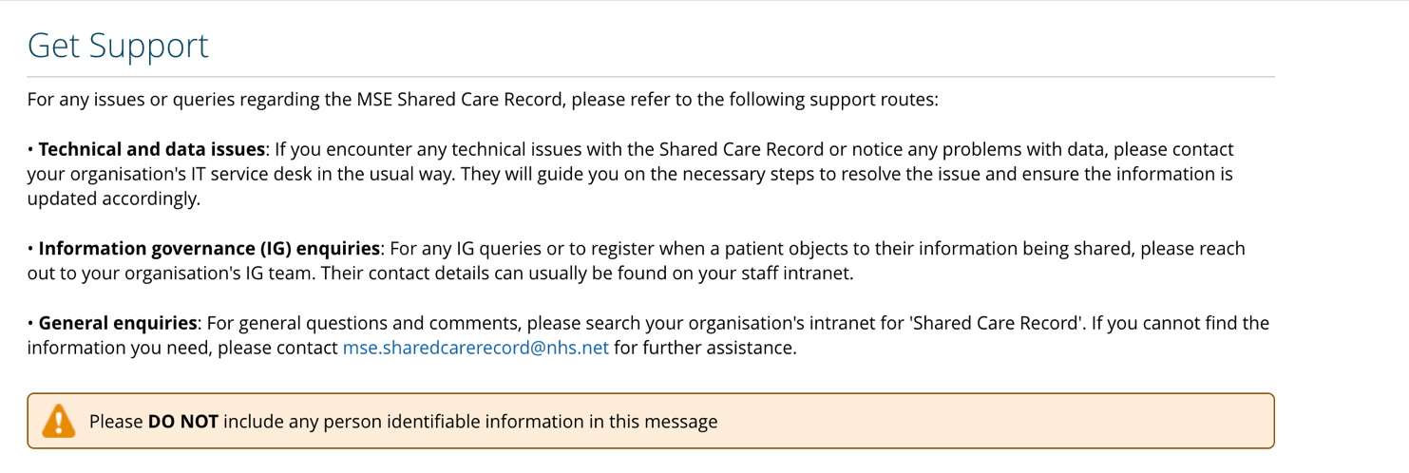

Selecting the understanding this data button will open a page on the MSE ICS website that contains a data visibility guide. It also has guidance on using the information in the Shared Care Record safely and effectively.
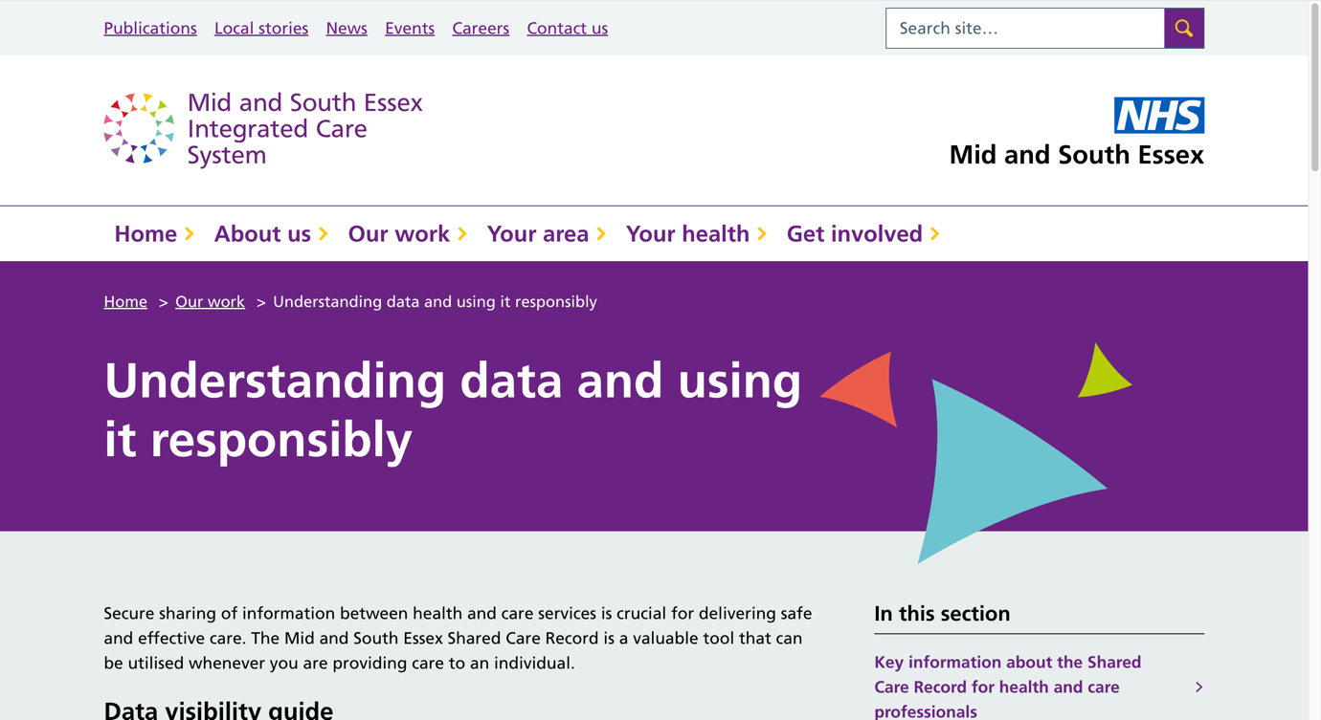

Selecting the training and key information button will open a page on the MSE ICS website that contains key Shared Care Record resources for health and social care professionals.
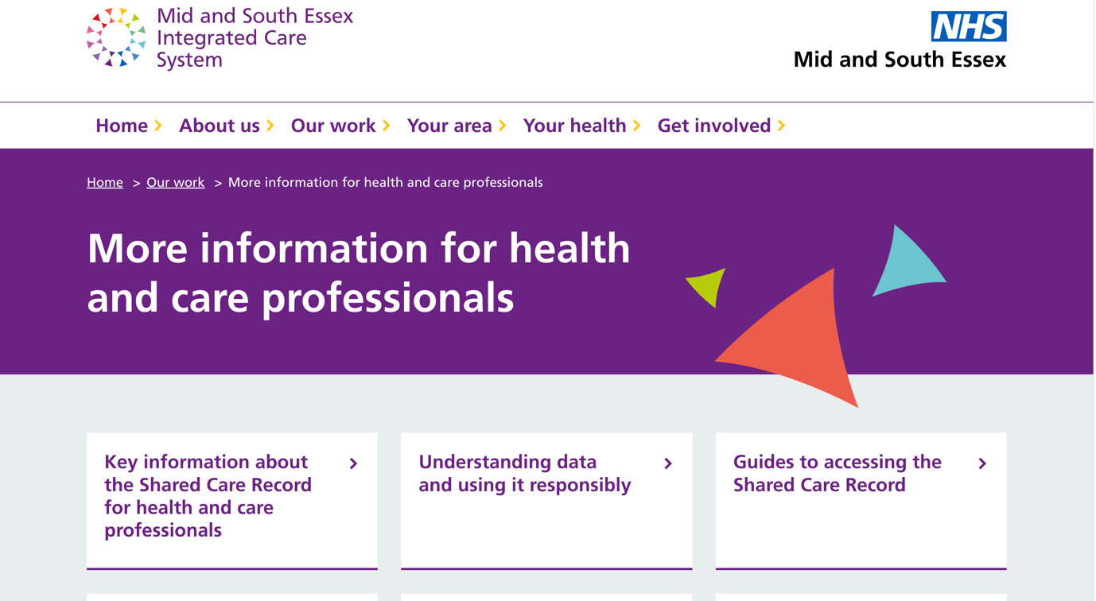

Additional resources
- Further information: https://midandsouthessex.ics.nhs.uk/sharedcarerecord
- Contact information for feedback: mse.sharedcarerecord@nhs.net

