Accessing the Shared Care Record via Mosaic Single Sign on: a quick reference guide

Introduction

Purpose of the guide
This guide explains how to access the Mid and South Essex Shared Care Record via Mosaic.

Target audience
Professionals who use Mosaic and want to access Shared Care Records.

Prerequisites and requirements
Access to the Mosaic system and the record displayed will always be that of the patient that you are currently viewing in the clinical system.

About access to the Shared Care Record
Access to the Shared Care Record is granted via single sign-on when you are signed into your own records system. This means that you do not need any additional login details and will only be able to view the Shared Care Record for the person whose record you are currently viewing.
If you encounter any issues accessing the Shared Care Record, please contact your IT service desk in the usual way.
Please note that the record shown is a test patient and does not contain any personal identifiable information.

Step-by-step instructions

Search for the persons record in Mosaic
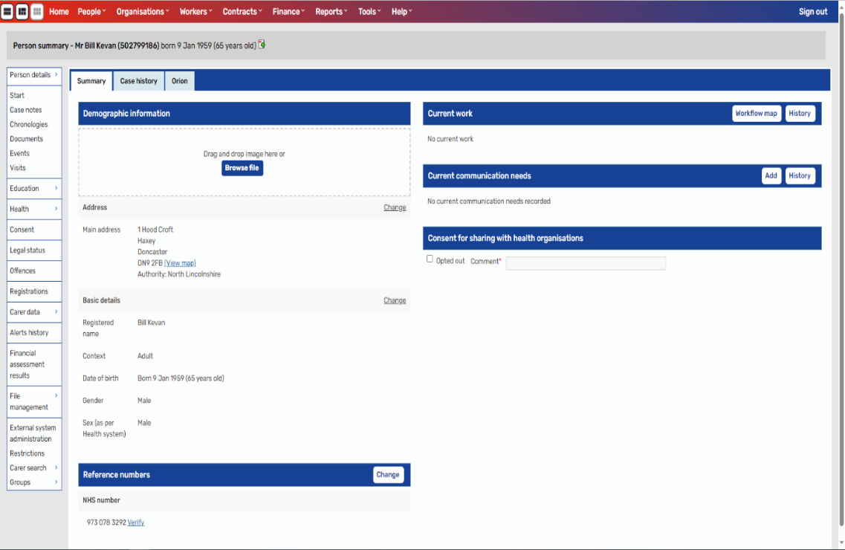

Select the Orion tab.
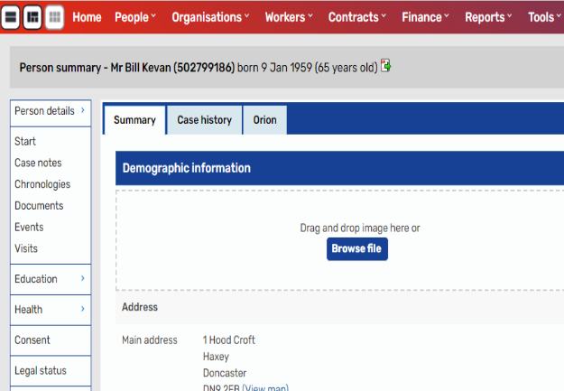

The person’s shared care record will be displayed.
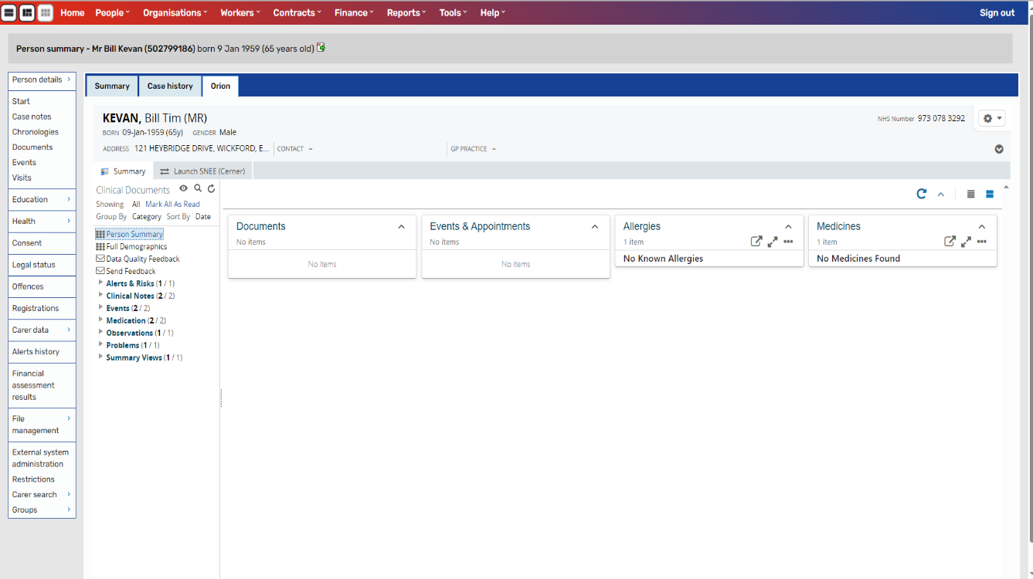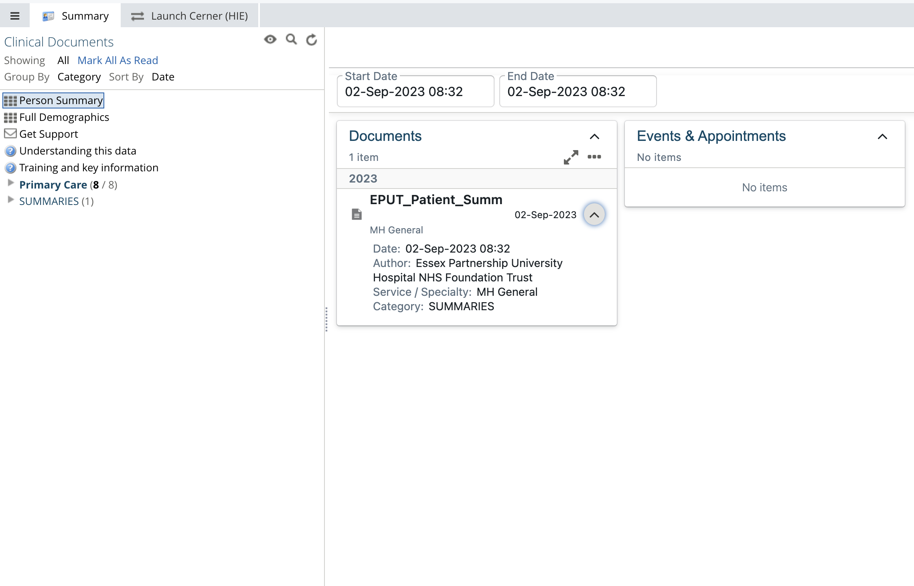

Launching the Cerner Health Information Exchange (HIE)

Load an individual’s record in the Shared Care Record.

Select the Launch Cerner (HIE) option next to the summary tab.
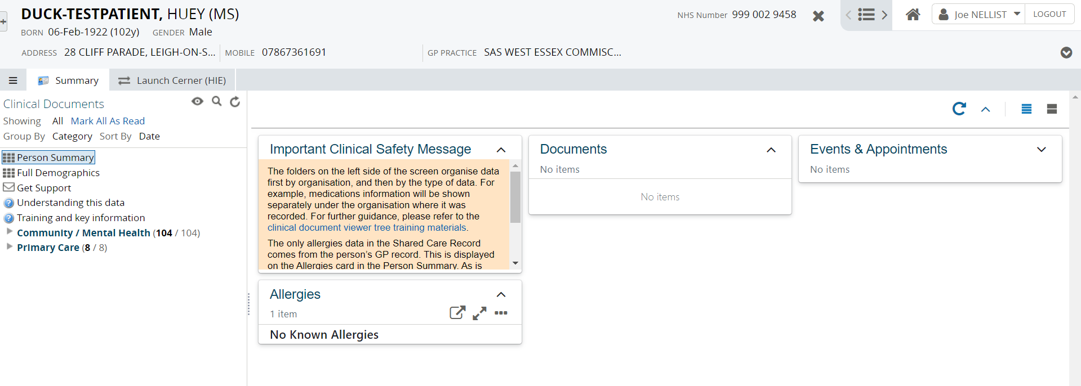

The Suffolk and North East Essex Cerner Health Information Exchange (HIE) system is launched for the patient in context.
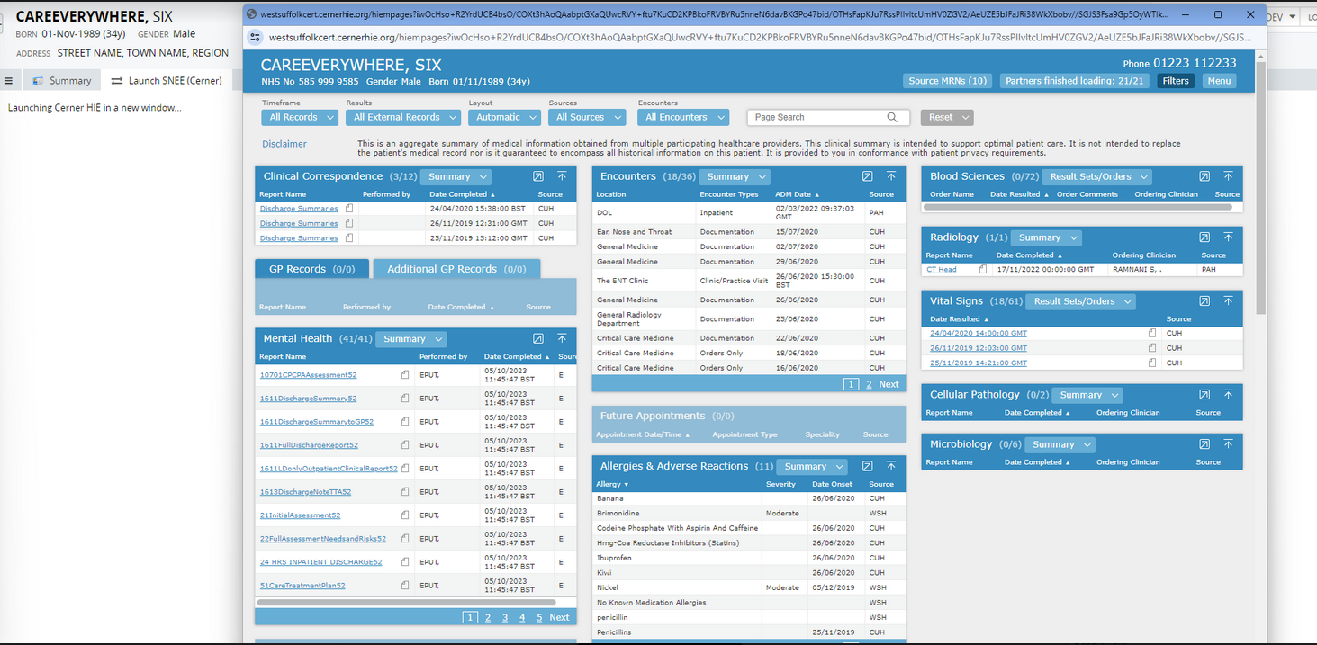

Additional resources
- Further information: https://midandsouthessex.ics.nhs.uk/sharedcarerecord
- Contact information for feedback: mse.sharedcarerecord@nhs.net

