Changes made to training materials to mitigate clinical hazards (20.08.24)

Issue 1 (allergies):
Added following section to ‘The person summary screen’ QRG:
Allergies dashboard card
The only allergies data in the Shared Care Record comes from the person’s GP record. This is displayed on the allergies card in the person summary. If a person has allergies recorded, this will display as ‘Known Allergies’. To see detailed information, click on the card.
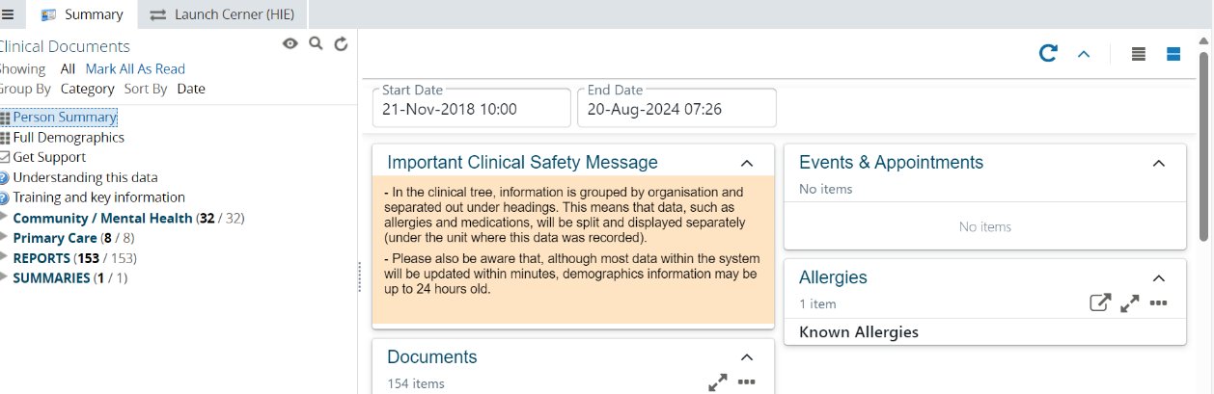
Detailed allergies and adverse reactions will be displayed in a pop-up window like the below.
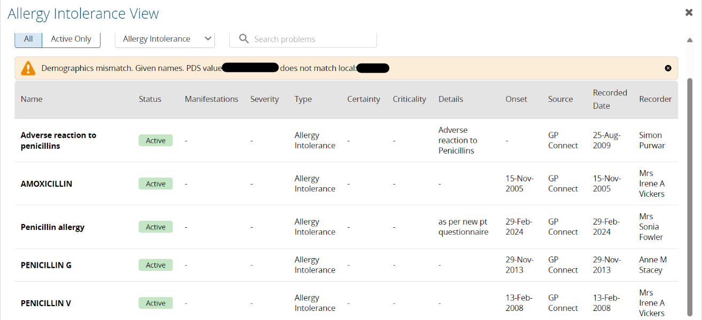
As is standard practice, please verify this information with the person you are caring for.

Issue 2 (EPUT document locations)
Added following section to ‘Navigating the clinical document viewer tree’ QRG:
Locating data from EPUT services
EPUT provides acute mental health services and community health services. Data from these services comes from different IT systems and is organised into different sections within the clinical document viewer tree. Users will find data from various EPUT services located in separate folders:

EPUT community health data can be found under the Community / Mental Health section.
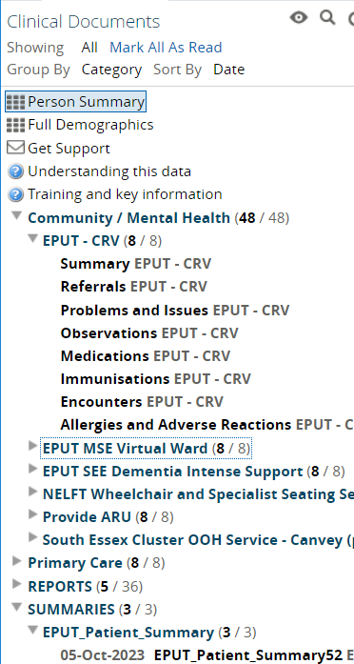

EPUT acute mental health data can be located under the Reports and Summaries sections.
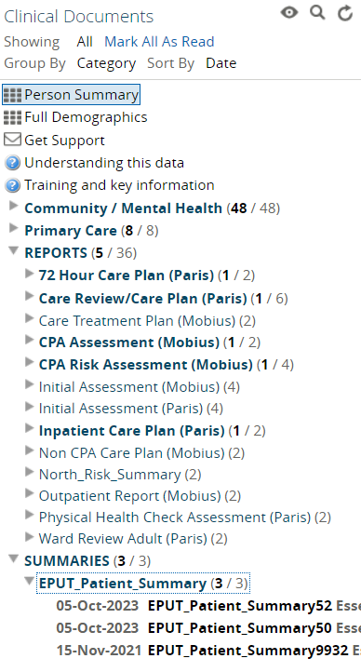

Issue 3 (unknown date):
Add the below section to the ‘Viewing documents in the clinical document viewer tree’ QRG
When opening documents via the dashboard card, you will see a folder called ‘Unknown Date’. This folder contains unstructured data from community and primary care meaning that it cannot be sorted into chronological order. The difference between structured and unstructured data is:
- Structured data: This is highly organised and easily searchable. This information is displayed in the interactive dashboards, such as the Person Summary or Medications Viewer sections.
- Unstructured data: This is more free-form and does not follow a specific format. It often includes text and documents. This type of data is stored in the clinical document tree.
To return to the standard view of the clinical document viewer, simply click on the Summary tab, or change the document grouping settings using the steps above.
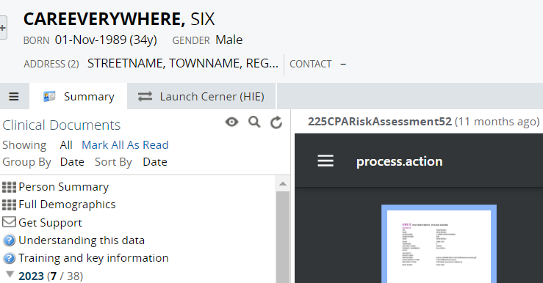

Issue 4 (error message with GP practice details):
Added following section to ‘Navigating the clinical document viewer tree’ QRG:
Error message when accessing primary care data
Primary care data is shared via GP Connect. In the unlikely event that a person is not registered with a GP practice that has enabled GP Connect sharing, the following message may be displayed:
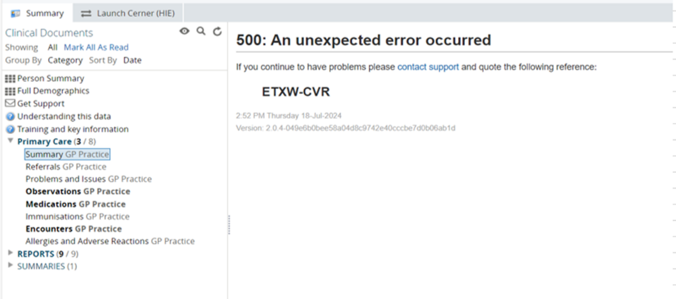
This message typically indicates one of the following:
- The patient is registered with a GP practice outside of Mid and South Essex (MSE), Suffolk and North East Essex (SNEE), or Hertfordshire and West Essex (HWE), and the Shared Care Record cannot retrieve GP Connect data.
- The patient has moved to a new area and is no longer registered with a GP practice that has enabled GP Connect sharing.
In these cases, GP data will not be available, and the error message will appear in the summary section under primary care.

Issue 5 (demographic data mismatch):
Added following section to ‘Navigating the clinical document viewer tree’ QRG:
Demographic mismatch alert

If demographic information provided by one IT system that does not match what is provided by another, a demographic mismatch alert will appear at the top of every sub-folder page.
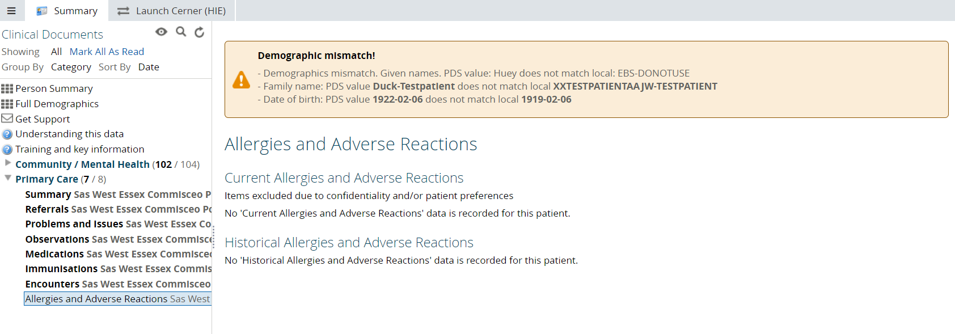

If you encounter this alert, please follow your standard procedures to verify the information with the person you are caring for, ensuring that the correct data is used throughout their care journey. You may want to update inaccurate data within your own IT system.

Issue 6 (tree layout for EPUT):
See above amendments for issue 2.

Issue 7 (timeout):
Added the below to the ‘Launching the Cerner Health Information Exchange from the Shared Care Record’ QRG
Session expiration
The Cerner HIE opens in a new browser window. To safeguard patient data and ensure the highest level of security, activity in this new window is not monitored by the MSE Shared Care Record.
To further protect patient information, the MSE Shared Care Record system will automatically timeout after 5 minutes of inactivity. You can maintain your session by periodically returning to the MSE Shared Care Record window to refresh it.
If your session in the MSE Shared Care Record times out, simply reopen the individual's record from your clinical system to continue accessing the information securely.

Issue 8 (EPUT document limit):
TBC

Additional change (not requested in clinical hazard meeting, but should aid navigation to key information
Added following section to ‘Navigating the clinical document viewer tree’ QRG:
Locating MSEFT discharge letters
To view discharge letters from Mid and South Essex Foundation Trust (MSEFT), navigate to the correspondence section within the clinical document viewer.
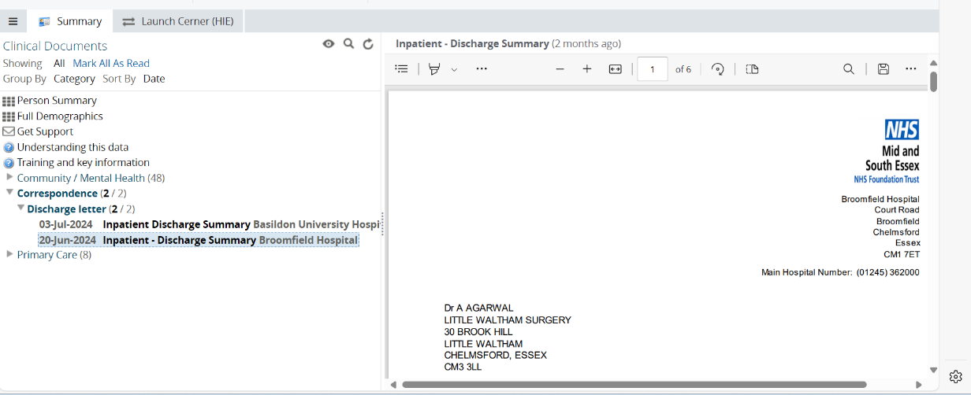

Amended copy for the important clinical message panel
Please scroll to read the full message:
The folders on the left side of the screen organise data first by organisation, and then by the type of data. For example, medications information will be shown separately under the organisation where it was recorded. For further guidance, please refer to the clinical document viewer tree training materials.
The only allergies data in the Shared Care Record comes from the person’s GP record. This is displayed on the Allergies card in the Person Summary. As is standard practice, please verify this information with the person you are caring for.
Most data in the system is updated within minutes. However, some information, such as demographic details, may take up to 24 hours to update.

