Accessing the Shared Care Record via EPUT Care Portal Single Sign On: a quick reference guide

Introduction

Purpose of the guide
This guide explains how to access the Mid and South Essex Shared Care Record via EPUT Care Portal.
The screenshots below have been supplied by Essex Partnership University NHS Foundation Trust (EPUT). If you encounter any issues accessing the Shared Care Record, please contact your IT service desk in the usual way.

Target audience
Professionals who use EPUT Care Portal and want to access the Shared Care Record.

Prerequisites and requirements
Access to EPUT Care Portal and the record displayed will always be that of the patient that you are currently viewing in the clinical system.

About access to the Shared Care Record
Access to the Shared Care Record is granted via single sign-on when you are signed into your own records system. This means that you do not need any additional login details and will only be able to view the Shared Care Record for the person whose record you are currently viewing.
If you encounter any issues accessing the Shared Care Record, please contact your IT service desk in the usual way.
Please note that the record shown is a test patient and does not contain any personal identifiable information.

Step-by-step instructions

Launch the EPUT Care Portal by opening the trusts intranet page then go to Tools, Clinical Systems and EPUT Care Portal.
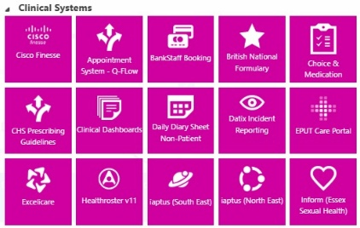
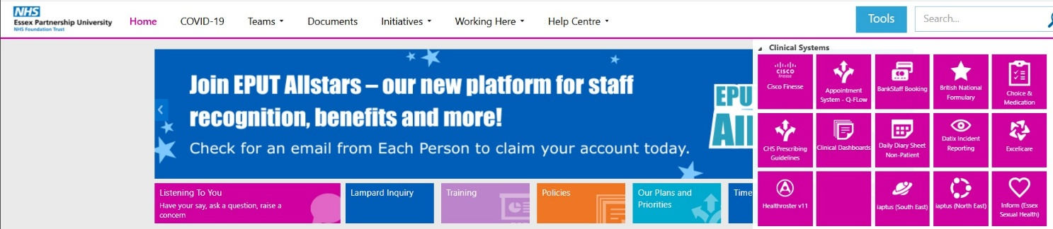



Note: The first time you open the EPUT Care Portal you may need to enter login details.

Username = your Windows username followed by @xsouthessex
Password = Your Window password.
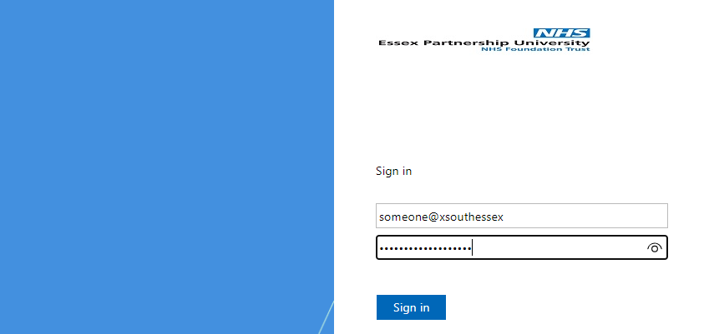
The next time you open EPUT Care Portal it should automatically sign you in using SSO (single sign on)

Choose and select a patient in the EPUT Care Portal then click Shared Care Records to load the MSC SCR
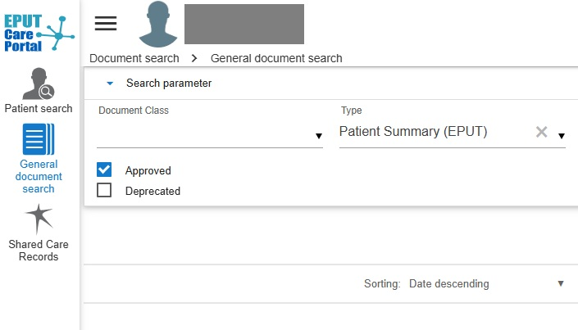

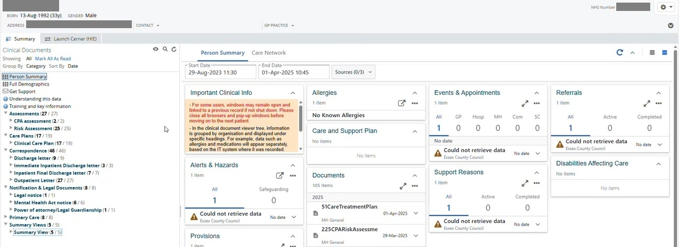
The person’s shared care record will be displayed.

Note: If you see 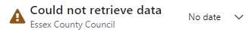this will indicate that no data has been found from that sharing partner.
Note: When ShCR has loaded if you see Module loader failed to load Close the window and re-try. If this does not work, try moving between partner information in the ShCR portal and come back to Person Summary.

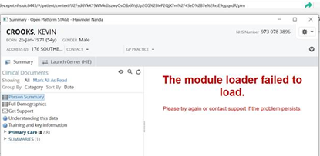

The Shared Care Record portal has a 5-minute time-out process. If MSE Shared Care remains idle for 5 minutes, a 15-second timeout window will appear, even if you are in the Cerner HIE (SNEE) portal. Click on 'Stay logged in' for both windows to remain open.
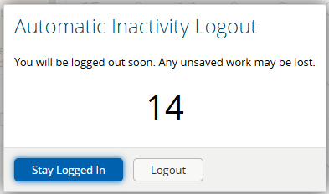

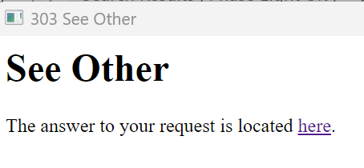
If you miss it, both Windows will close and Cerner will have the following message in the Window:

Step-by-step instructions Navigating the clinical record.

Information in the clinical document viewer tree is arranged by organisation first, and then type of information. This is accessible from on the left-hand side of the screen.
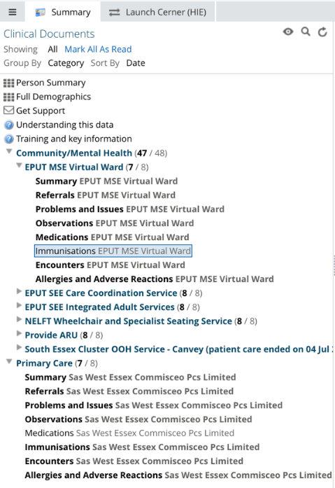

When you expand the organisation folders, you will be presented with subfolders which include summary, referrals, problems and issues, observations, medications, immunisations, and encounters.
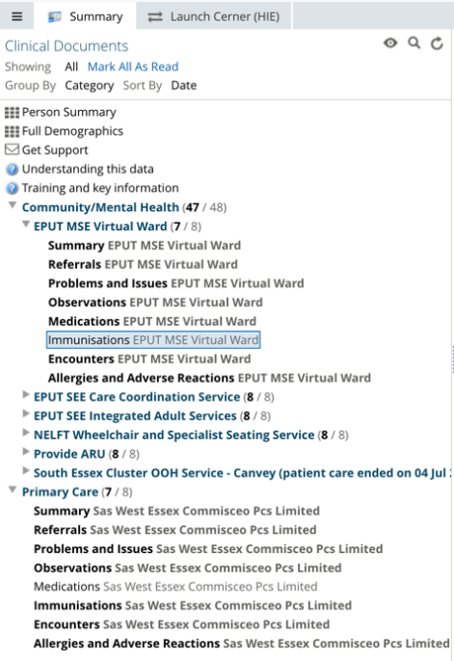

Hovering your mouse over a subfolder will present further information, including category, subcategory, service, author, care setting, data source and organisation.
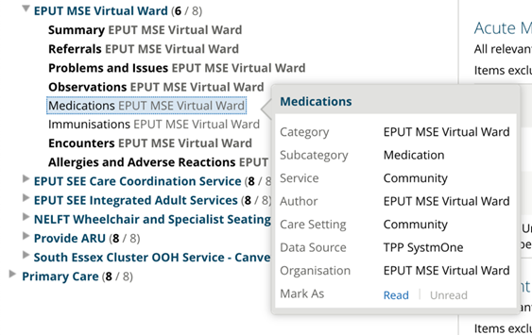

Demographic mismatch alert

If the demographic information provided by one IT system that does not match what is provided by another, a demographic mismatch alert will appear at the top of every subfolder page.
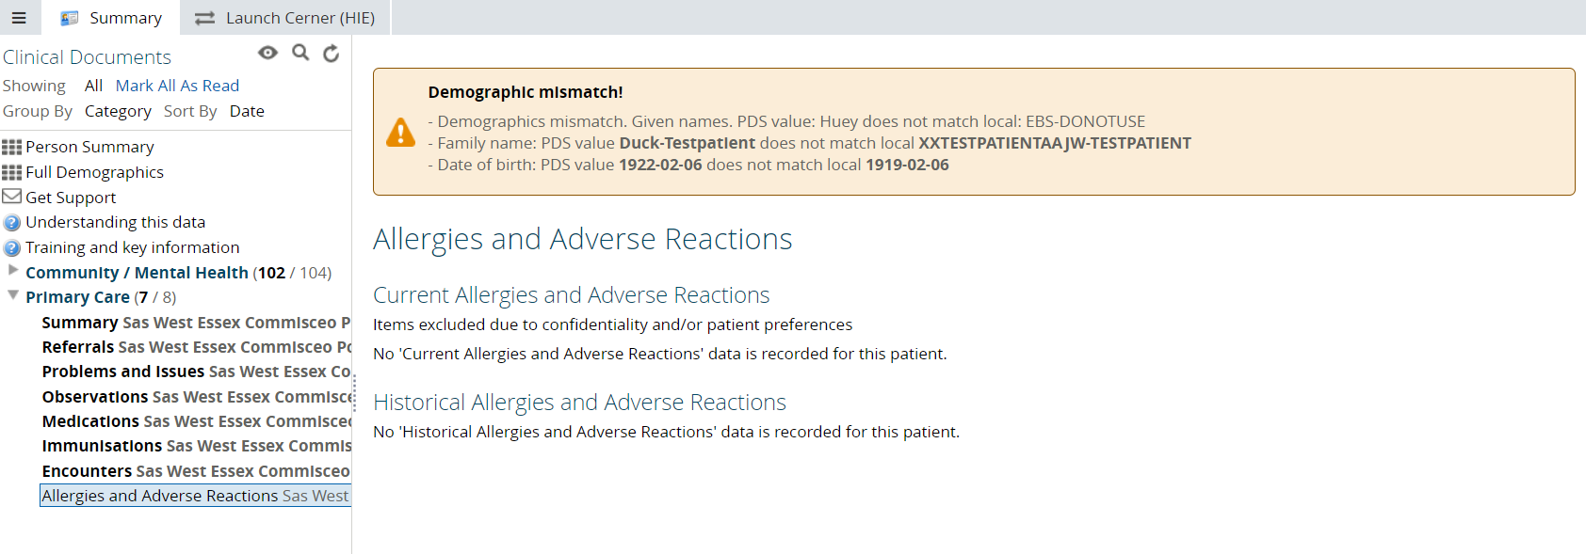

If you encounter this alert, please follow your standard procedures to verify the information with the person you are caring for, ensuring that the correct data is used throughout their care journey. You may want to update inaccurate data within your own IT system.

Summary subfolder within clinical document viewer tree

When you select summary subfolder, it will display the following information. When you open the next document the first will close automatically.
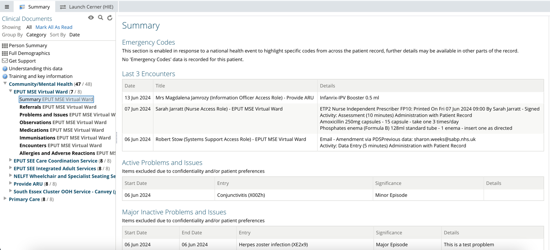

When you select referral subfolder, it will display the following information.
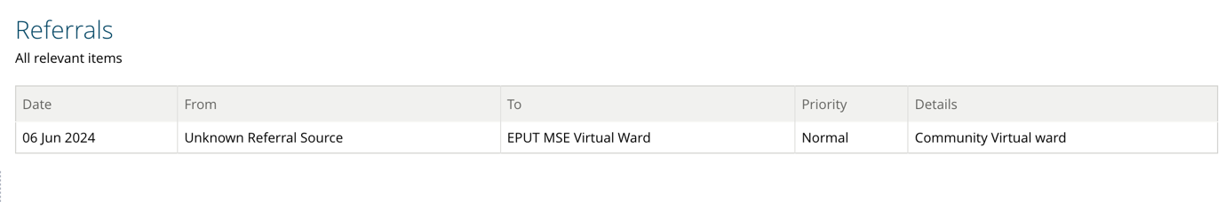

When you select problems and issues subfolder, it will display the following information.
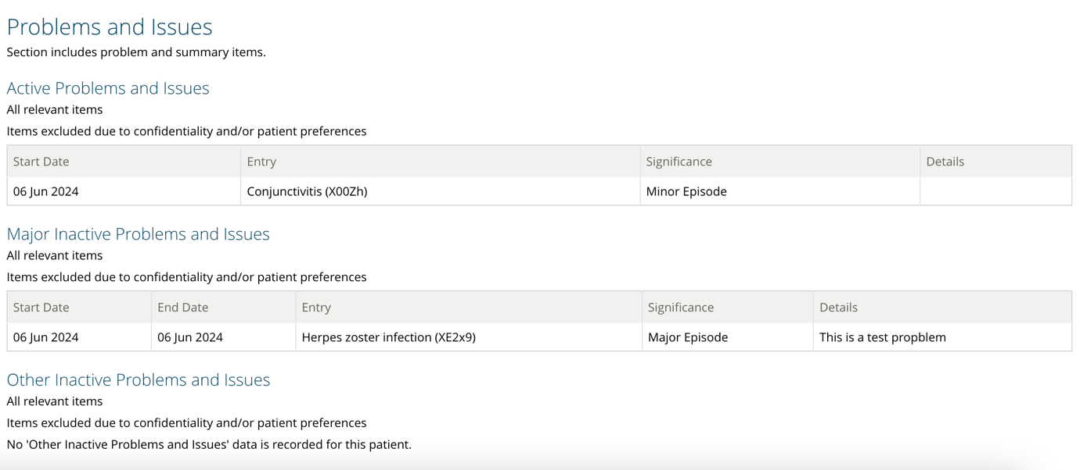

When you select observations subfolder, it will display the following information.
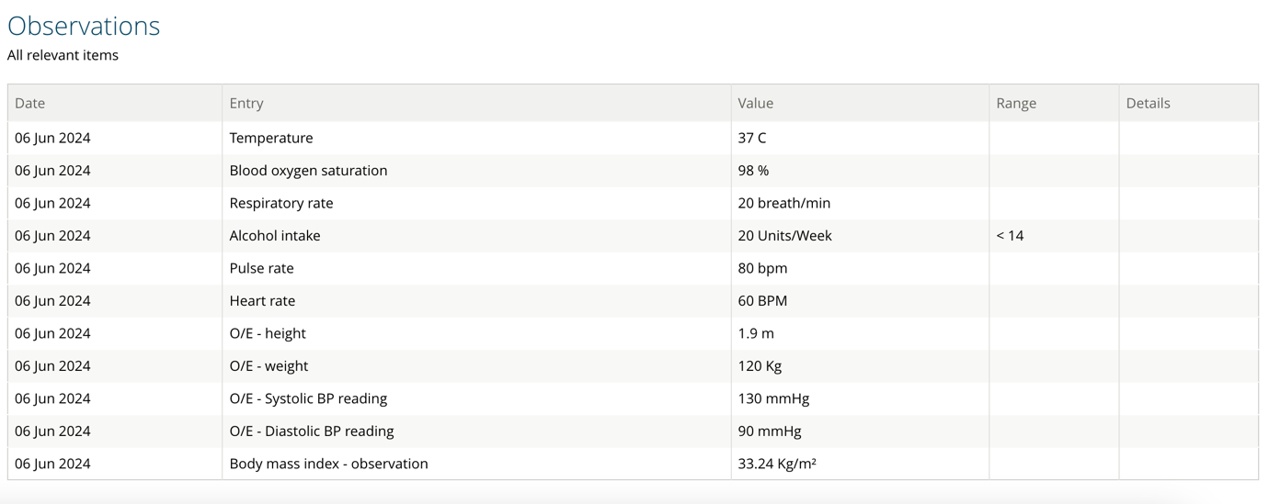

When you select medications subfolder, it will display the following information.
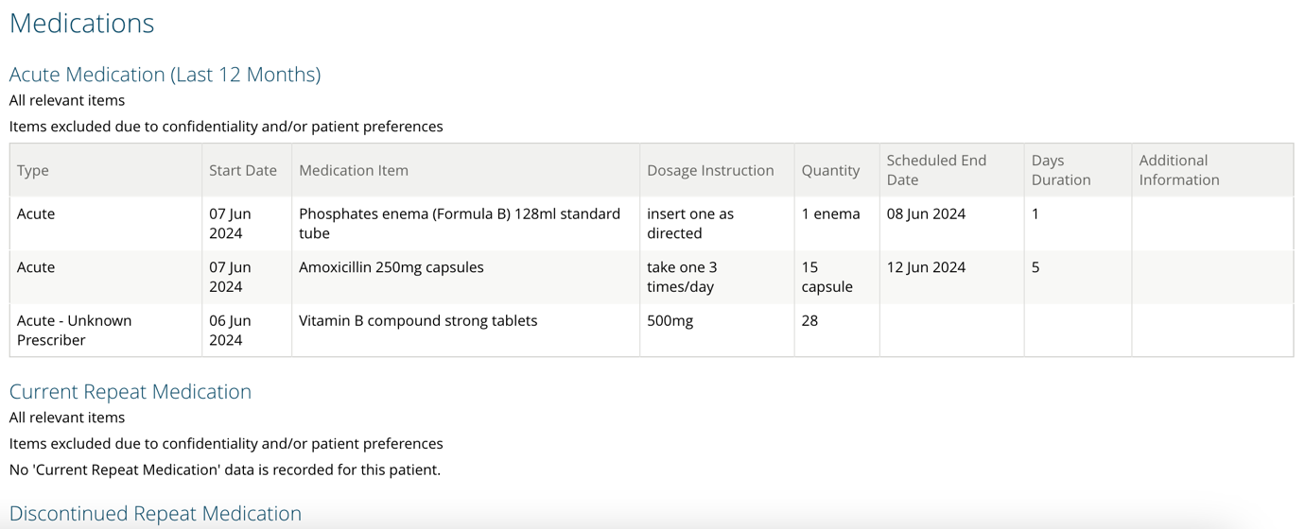

When you select immunisations subfolder, it will display the following information.
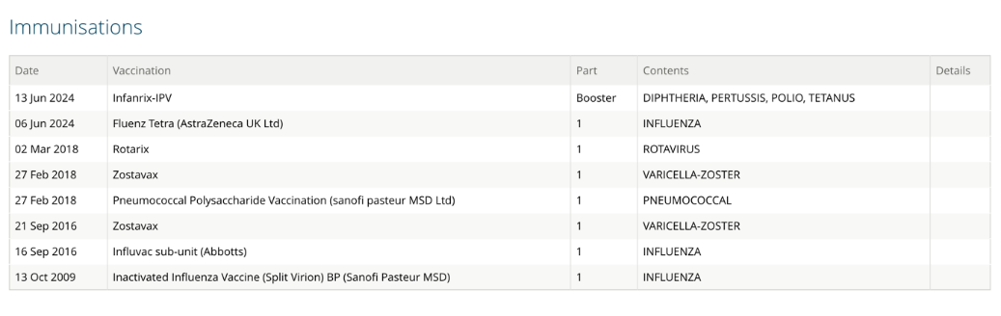

When you select encounters subfolder, it will display the following information.
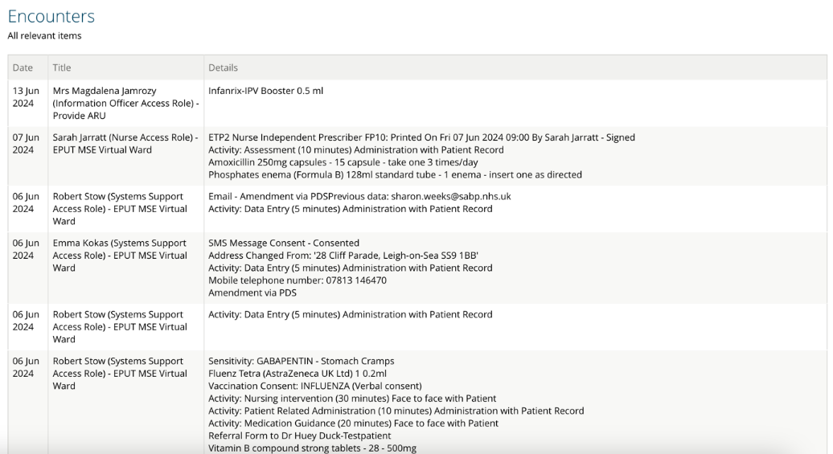

Documents can be accessed within the Person Summary Panel View as well.
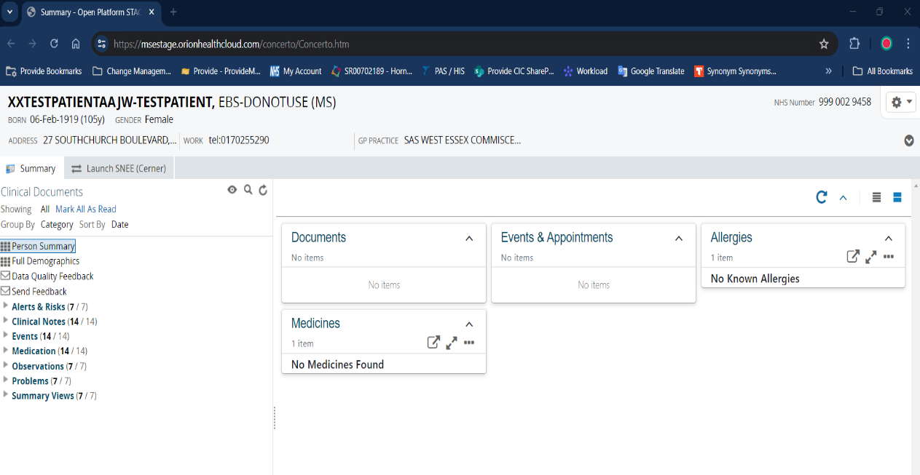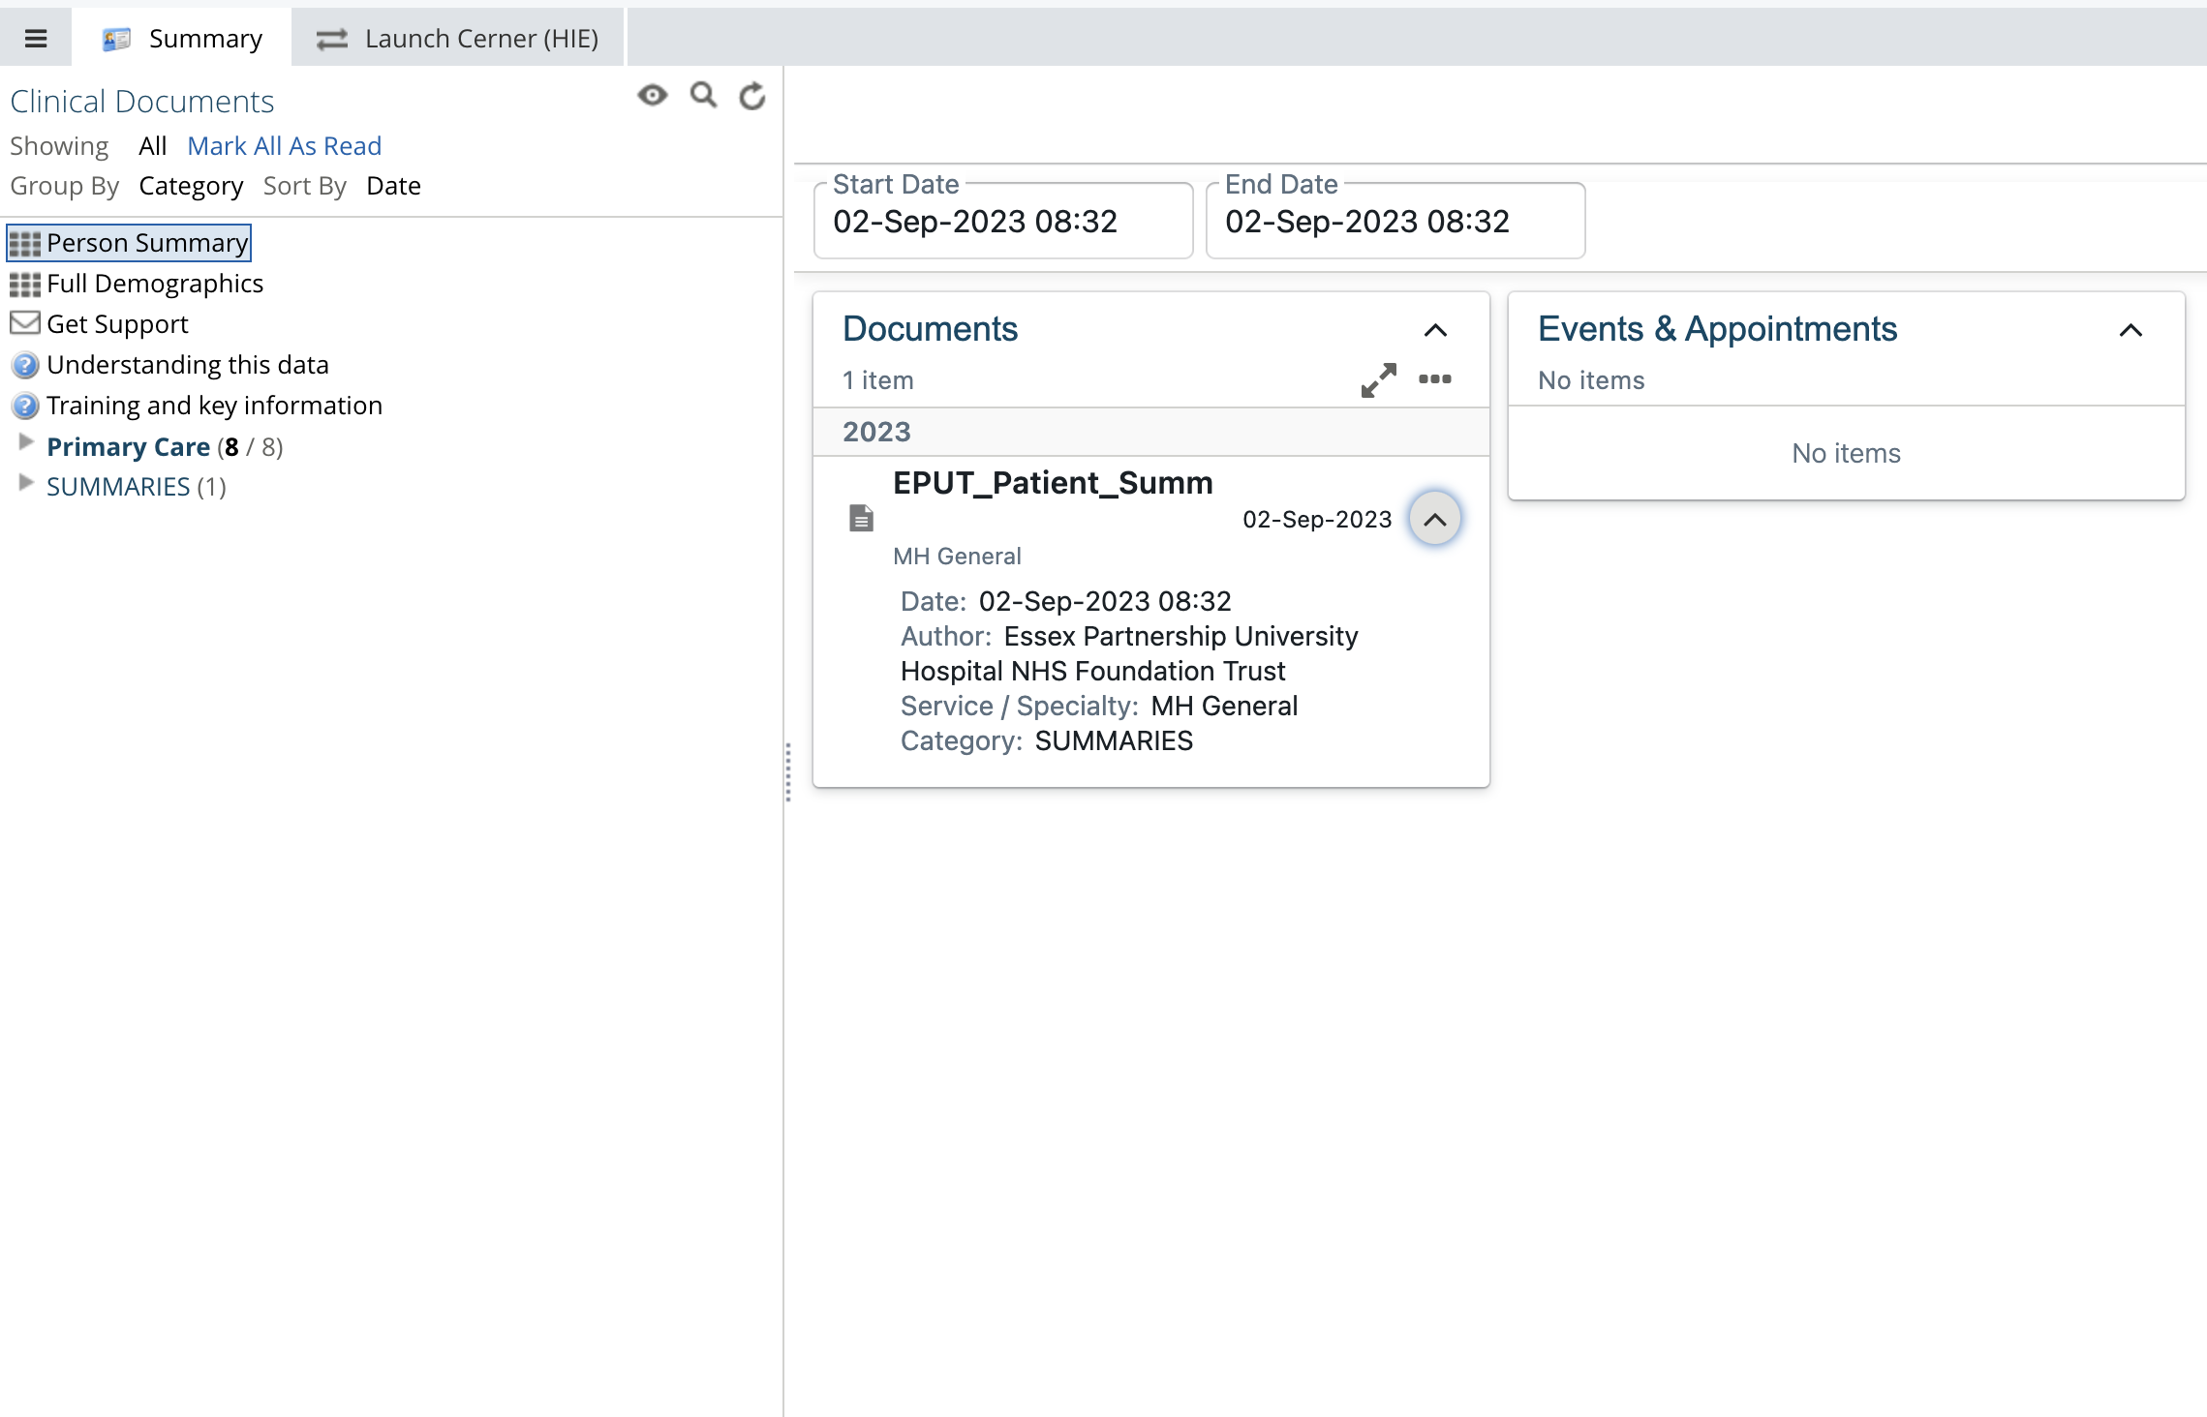

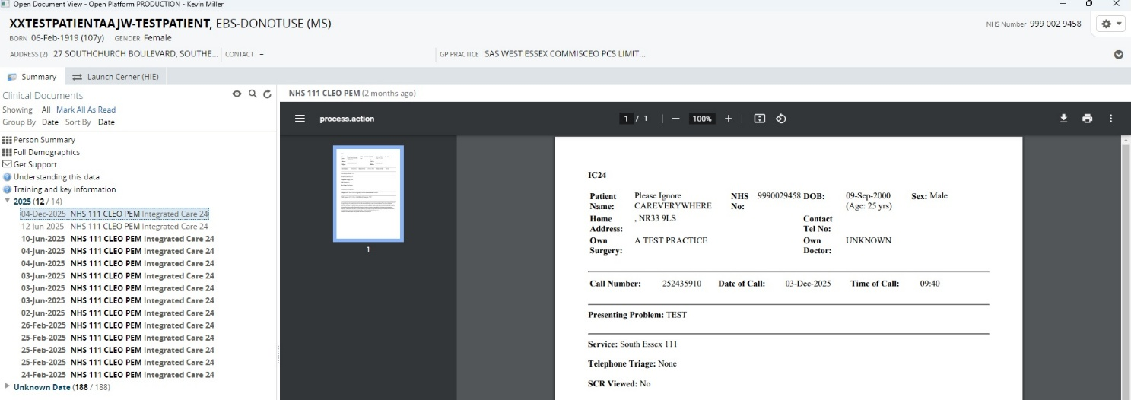

After viewing the document click on Person Summary to return to the panel view.
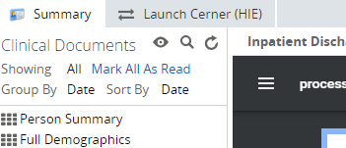

Locating data from EPUT services
EPUT provides acute mental health services and community health services. Data from these services comes from different IT systems and is organised into different sections within the clinical document viewer tree. Users will find data from various EPUT services located in separate folders:

EPUT community health data can be found under the Community/Mental Health section.
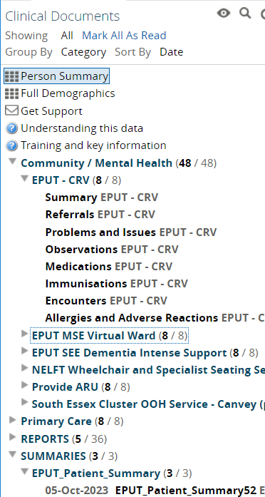

EPUT acute mental health data can be located throughout the tree view.
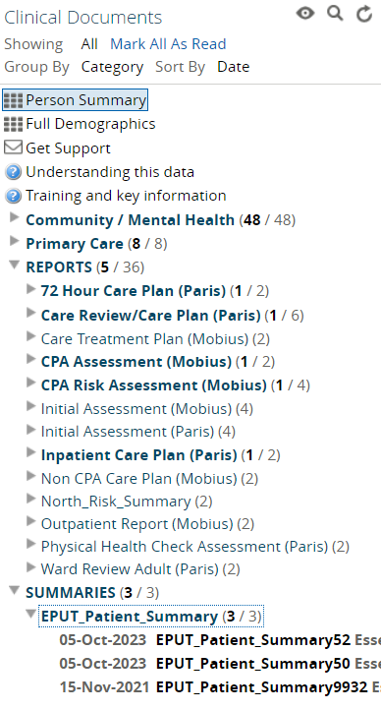
Note: EPUT are working towards sharing more MH patient data with the MSE Shared Care record. Please look out for additional categories and sub-folders in the near future.

Locating MSEFT discharge summaries letters

To view discharge summaries and letters from Mid and South Essex Foundation Trust (MSEFT), navigate to the correspondence section within the clinical document viewer.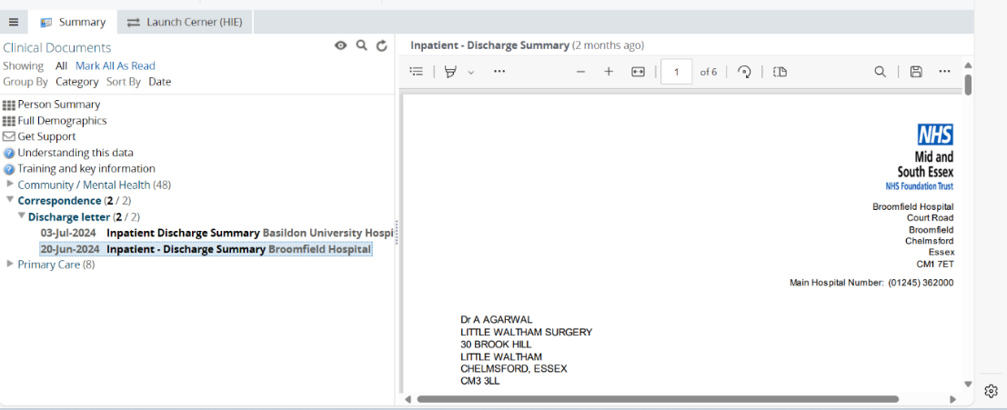

Error message when accessing primary care data

Primary care data is shared via GP Connect. In the unlikely event that a person is not registered with a GP practice that has enabled GP Connect sharing, the following message may be displayed:
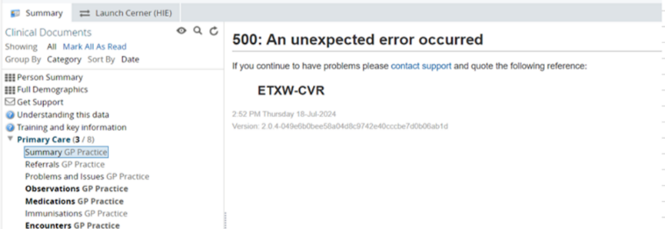
This message typically indicates one of the following:
- The patient is registered with a GP practice outside of Mid and South Essex (MSE), Suffolk and North East Essex (SNEE), or Hertfordshire and West Essex (HWE), and the Shared Care Record cannot retrieve GP Connect data.
- The patient has moved to a new area and is no longer registered with a GP practice that has enabled GP Connect sharing.

In these cases, GP data will not be available, and the error message will appear in the summary section under primary care.

Accessing information beyond Mid and South Essex
You can still access patient information from East of England and Greater London via the Cerner Health Information Exchange (HIE) / SNEE Shared Care Record. The direct link to this is now located in MSE Shared Care Record, helping teams navigate between local and regional information more easily.

Launching the Cerner Health Information Exchange (HIE) / SNEE Shared Care Record portal

Load an individual’s record in the Shared Care Record.

Select the Launch Cerner (HIE) / SNEE Shared Care Record option next to the Summary tab.
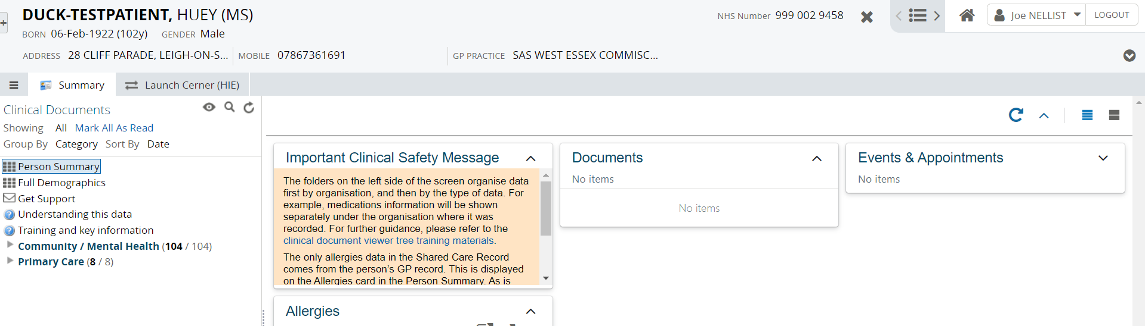

The Suffolk and North East Essex Cerner Health Information Exchange (SNEE) / Cerner HIE system is launched for the patient in context.
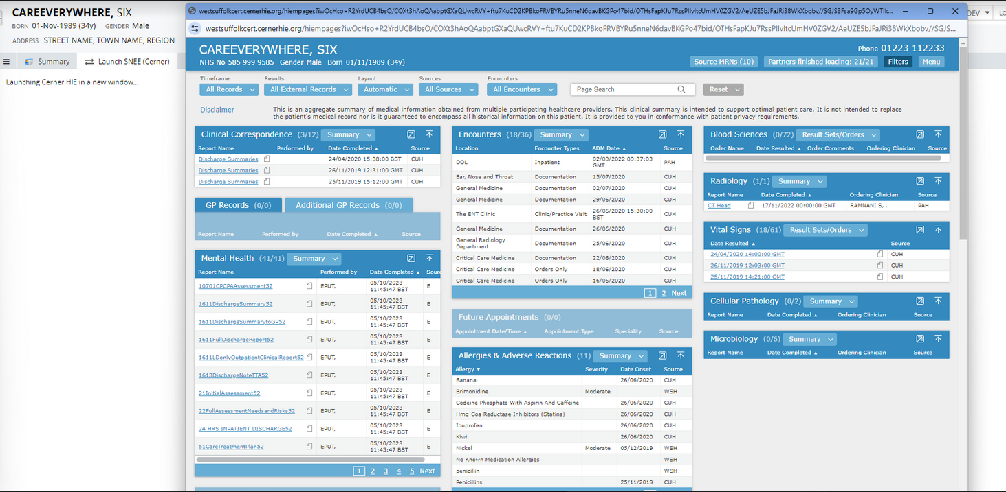
ALERT! Additional windows will now open when launching the Shared Records portals. Please close any existing Shared Care Records windows including Cerner HIE portal, before searching for a new patient within the EPUT Care Portal. This is to ensure you are reviewing the correct patient data. For any additional information required to support your clinical decision, please contact the practitioner.

Additional resources
- Further information: https://midandsouthessex.ics.nhs.uk/sharedcarerecord
- Contact information for feedback: mse.sharedcarerecord@nhs.net

