Wrist Sprain

What is a wrist sprain?
A sprained wrist occurs when the ligaments of the ankle are injured. Ligaments are strong bands of tissue that connect one bone to another and help hold joints together.

How is it caused?
A sprained wrist occurs when a ligament is forced into an abnormal position, causing it to overstretch.

How is it diagnosed?
Wrist sprains occur in different severities. The 3 grades of wrist sprain are:
Grade 1 – a mild strain (typically involving less than 10% the fibres).
Grade 2 – a partial ligament tear (typically involving between 11-49% of the fibres)
Grade 3 – a complete ligament tear (typically involving more than 50% of the fibres)

Diagnosis is generally made clinically following a history taking and physical examination.

You may be referred for an X-Ray if an wrist fracture is suspected. If your wrist is not recovering as expected with rehabilitation you may be referred for further investigations such as an MRI scan.

What are the symptoms?
- Pain and tenderness around the wrist
- Swelling and discolouration: may be more indicative of a more severe sprain.
- Joint instability.
- Reduced movement and stiffness

What can I do?
In the early stages (48-72 hours)

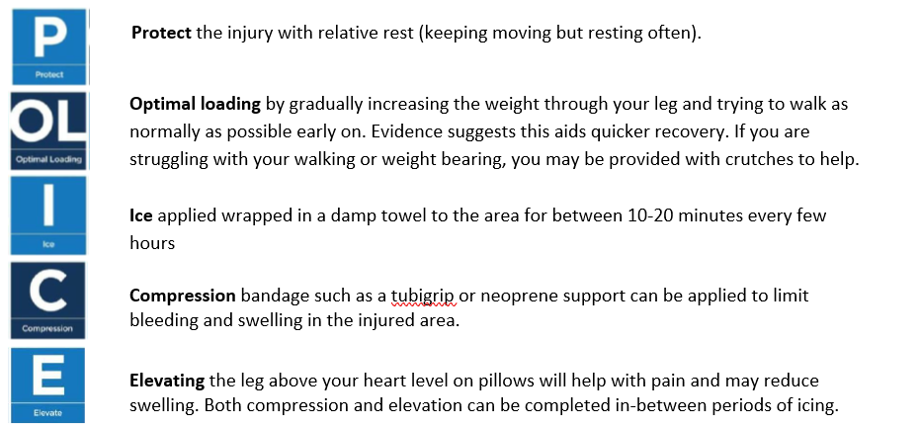

Over-the-counter analgesia, such as paracetamol or anti inflammatories such as ibuprofen may also help to reduce your symptoms. If you require further information on pain relief, speak to your GP or pharmacist.

Progressive Exercise
Exercise is an essential part of your recovery following a wrist sprain. They should be done as pain allows, with some discomfort being acceptable. If a sharp shooting pain is provoked then ease off. As your pain reduces and your movement improves consider progressing to the more difficult exercises.

Wrist Splint:
In more severe cases you may be required to wear a splint. A splint is removable and is generally worn for between 2 and 6 weeks to help make the wrist more comfortable whilst it is healing. You can normally remove the splint at rest, at night time and for bathing and showering. You only need to wear the splint when you are using the wrist. As you recover you will be able to reduce the amount of time wearing the splint as the pain settles and symptoms ease.

Factors influencing pain and recovery
During your recovery a number of other factors can influence your pain levels. Keep the following factors in mind to help move the healing process along:

Look after yourself
Pain is not usually simply a physical problem. Your general well-being can make you vulnerable to pain and your wellbeing can also be made worse by pain. Looking after your general health and well-being will help recovery. There is helpful advice on this website: https://www.nhs.uk/oneyou

Reduce stress and anxiety
It is normal for people with pain to have stress, anxiety and change in mood. This may affect your ability to cope with the pain and may influence your pain levels. Help is available if you are being affected by stress, anxiety or low mood – see the links below or discuss with your practitioner.

It is important that your whole nervous system is in a healthy state to aid recovery. If your brain is stressed or overworked this may slow recovery. Relaxation is an important part of your recovery. Simple relaxation techniques may help manage pain and stress. Try to set aside some time each day to relax – you can use relaxation techniques as linked below, or simply an activity you enjoy – reading, deep breathing, sitting in the garden, singing – whatever relaxes you.

Find help and support here: https://www.nhs.uk/oneyou/every-mind-matters/
https://www.northessexiapt.nhs.uk/west-essex

Physical Activity
Exercise improves fitness, confidence with movement and strength. It can also help reduce your stress and tension and improve your mood and quality of sleep, helping support you to return to normal activities. Perhaps you could simply start by trying to walk for 10 minutes per day.

Alcohol
Avoid alcohol in the early stages of healing (first three days). Evidence has shown this can slow down recovery and increase the chances of re-injury. https://www.drinkaware.co.uk/

Sleep
Sleep is very important for your wellbeing. Poor sleep quality, and lack of sleep can make managing pain more difficult. Consistently getting 6-9 hours is recommended. Get help and tips here:
https://www.nhs.uk/live-well/sleep-and-tiredness/

Smoking
Smoking can also impact how quickly tissues can heal and affect pain levels. For help with stopping smoking https://www.essexlifestyleservice.org.uk/stop-smoking/ https://www.nhs.uk/better-health/quit-smoking/

How long will it last?
Mild sprains would be expected to recover within 3-4 weeks.
Moderate or severe sprains treated conservatively would be expected to recover within 6-8 weeks.

If your symptoms have persisted or worsen despite following the advice and exercise provided in this leaflet you will need to visit your GP surgery again.

Is there anything I should avoid?
- Overstretching within the first few weeks can put too much strain on the healing tissue.
- Returning too quickly to activity involving high speed movement within the first 30-50 days has the potential to cause further injury. A gradual re introduction to running is advised.

What other options are there?
Physiotherapy:
Manual mobilisation of joints combined with exercise therapy has been shown to result in short term increases in ankle range of motion and reductions in pain.

If you require 1:1 physiotherapy treatment please fill out a self-referral form which can found at https://eput.nhs.uk/our-services/essex/west-essex-community-health-services/adults/rehabilitation/musculo-skeletal-physiotherapy and send to epunft.mskphysio@nhs.net

