Hamstring Strains

What is a hamstring strain?
A hamstring injury is a strain or tear to the group of tendons or large muscles at the back of the thigh. They most often occur at the middle of the back of the thigh where the muscle joins its tendon or at the base of the buttocks.

How is it caused?
A hamstring injury can occur if any of the tendons or muscles are stretched beyond their limit.
They often occur during sudden, explosive movements, such as sprinting, lunging or jumping. But they can also occur more gradually, or during slower movements that overstretch your hamstring.

Hamstring injuries are more likely to occur:
- with increasing age
- if you have weak hamstring muscles, especially in comparison to your quadriceps (muscles on the front of the thigh)
- if you have previously injured your hamstring muscles
- during the later stages of competition
- if you have had a previous major knee injury

How is it diagnosed?
Hamstring injuries occur in different severities. The 3 grades of hamstring injury are:
Grade 1 – a mild muscle pull or strain(typically involving less than 10% of hamstring muscle fibres).
Grade 2 – a partial muscle tear (typically involving between 11-49% of the fibres)
Grade 3 – a complete muscle tear (typically involving more than 50% of the fibres)

Diagnosis is generally made clinically following a history taking and physical examination. If a more severe injury is suspected or your symptoms are not improving as expected then further investigations such as an Ultrasound Scan or MRI may be required.

What are the symptoms?
Mild hamstring strains (grade 1) may not be painful until after the activity is over. There may be a sensation of cramp or tightness and a slight feeling of pain when the muscle is stretched or
contracted. A feeling of pain may be reported with sitting or while walking uphill or ascending stairs.

Partial hamstring tears (grade 2) will usually cause sudden pain and tenderness at the back of your thigh and are usually more painful and tender. There may also be some swelling and bruising at the back of your thigh and you may have lost some strength in your leg. Limping is likely during walking and occasional sudden twinges of pain during activity may occur. Bending the knee against resistance will cause pain and there may be some difficulty in fully straightening the knee.

Severe hamstring tears (grade 3) will usually be very painful, tender, swollen and bruised. There may have been a "popping" sensation at the time of the injury. Walking is likely to be very difficult.

What can I do?
In the early stages (48-72 hours)

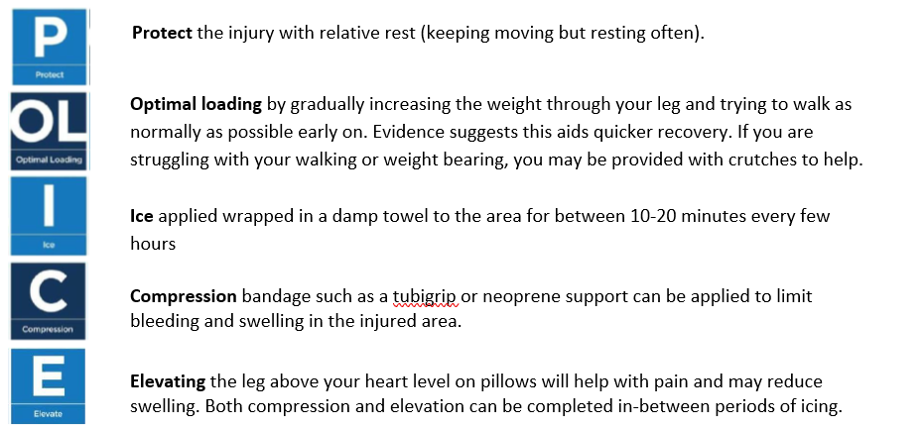

Over-the-counter analgesia, such as paracetamol, may also help to reduce your symptoms. If you require further information on pain relief, speak to your GP or pharmacist.

Progressive Exercise
Exercise is an essential part of your recovery following a hamstring injury. Specific exercise regimes have been shown to help prevent injuries reoccur. They should be done as pain allows, with some discomfort being acceptable. If a sharp shooting pain is provoked then ease off. As your pain reduces and your movement improves consider progressing to the more difficult exercises.

Factors influencing pain and recovery
During your recovery a number of other factors can influence your pain levels. Keep the following factors in mind to help move the healing process along:

Work
You may be worried about continuing with work, or other responsibilities. It is important to discuss these fears with your practitioner. Remaining at work usually leads to a quicker recovery even if you have to work with modified activities.

Having poor posture does not cause back pain. There is no perfect posture. Staying in one position for long periods can be a factor in your pain. It is important to plan regular breaks and change posture regularly.

Your relationship with your boss and colleagues, job enjoyment, feeling supported at work and returning to work are all very important in helping your recovery. Speak to your employer if you need support at work.

Painkillers
Painkillers may help to manage your pain but should only be taken for a short period. Paracetamol is not usually effective for sciatica. Painkillers do not speed up your recovery. They should always be used with other options such as exercise or other improvements to your well-being.

Look after yourself
Pain is not usually simply a physical problem. Your general well-being can make you vulnerable to pain and your wellbeing can also be made worse by pain. Looking after your general health and well-being will help recovery. There is helpful advice on this website: https://www.nhs.uk/oneyou

Reduce stress and anxiety
It is normal for people with pain to have stress, anxiety and change in mood. This may affect your ability to cope with the pain and may influence your pain levels. Help is available if you are being affected by stress, anxiety or low mood – see the links below or discuss with your practitioner.

It is important that your whole nervous system is in a healthy state to aid recovery. If your brain is stressed or overworked this may slow recovery. Relaxation is an important part of your recovery. Simple relaxation techniques may help manage pain and stress. Try to set aside some time each day to relax – you can use relaxation techniques as linked below, or simply an activity you enjoy – reading, deep breathing, sitting in the garden, singing – whatever relaxes you.

Find help and support here: https://www.nhs.uk/oneyou/every-mind-matters/
https://www.northessexiapt.nhs.uk/west-essex

Physical Activity
Exercise improves fitness, confidence with movement and strength. It can also help reduce your stress and tension and improve your mood and quality of sleep, helping support you to return to normal activities. Perhaps you could simply start by trying to walk for 10 minutes per day.

Alcohol
Avoid alcohol in the early stages of healing (first three days). Evidence has shown this can slow down recovery and increase the chances of re-injury. https://www.drinkaware.co.uk/

Sleep
Sleep is very important for your wellbeing. Poor sleep quality, and lack of sleep can make managing pain more difficult. Consistently getting 6-9 hours is recommended. Get help and tips here:
https://www.nhs.uk/live-well/sleep-and-tiredness/

Nutrition and weight
Being overweight can increase the physical strain on the body and also contribute to inflammation in your body. Make sure you eat a balanced diet. Adult weight management services are available free to Essex residents here: https://acelifestyle.org/weight-management

Smoking
Smoking can also impact how quickly tissues can heal and affect pain levels. For help with stopping smoking https://www.essexlifestyleservice.org.uk/stop-smoking/ https://www.nhs.uk/better-health/quit-smoking/

How long will it last?
The length of time it takes to recover from a hamstring strain or tear will depend on how severe the injury is. Less severe injuries (grade 1) may take a few days to heal, whereas it could take weeks or several months to recover from a more severe injury (grade 2 or 3).

You may need the guidance of a physiotherapist to help you return to normal activity:
- If your injury is more severe;
- If you wish to return to sports involving high speed movements; or
- If your symptoms have persisted despite following the advice and exercise provided in this leaflet.

If you require 1:1 physiotherapy treatment please fill out a self-referral form which can found at https://eput.nhs.uk/our-services/essex/west-essex-community-health-services/adults/rehabilitation/musculo-skeletal-physiotherapy and send to epunft.mskphysio@nhs.net

Is there anything I should avoid?
- Overstretching within the first few weeks can put too much strain on the healing tissue.
- Returning too quickly to activity involving high speed movement has the potential to cause further injury.

What other options are there?
The vast majority of hamstring injuries recover without the need for more invasive treatment. However, in more severe cases where there has been a complete rupture of the hamstrings where they attach at the base of buttock, you are likely to be referred to an orthopaedic surgeon to discuss the possibility of surgery to repair the tendons.

