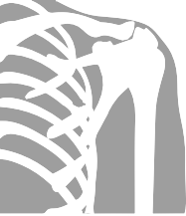

Shoulder Hydrodilatation

# Why have I been offered this treatment?

Your specialist has diagnosed a frozen shoulder which is a painful condition which causes reduced movement of the shoulder joint.

# What is involved?

Hydrodilatation involves stretching the capsule of the joint by injecting a mixture of sterile saline, local anaesthetic and steroid. This opens up the joint and releases sticky adhesions within the joint. The Radiologist performs the procedure in the Xray department using ultrasound guidance to ensure the injection is accurately placed.

You will be asked to lie on your back with your hand by your side. The skin will be cleaned and local anaesthetic will be given to numb up the area. A fine needle will be introduced onto the surface of the shoulder joint under ultrasound guidance..

The saline, steroid and further local anaesthetic will then be given.

# Is it safe?

It is a safe procedure. There is a very small risk of infection, as with any joint injection. There is a risk that it may not work (in about 30%). There is a small risk of bleeding. You must inform the department if you are taking blood thinning drugs (anti-coagulants) e.g Warfarin.

# What can I expect to feel during and after the procedure?

Once the area is numbed up you should feel very little. There may be some pushing and pressure sensation. Occasionally people have described a feeling of excess fluid in the shoulder. These symptoms should resolve quickly.

# Does it work?

Nationally this procedure has a success rate of over 70% in improving the movement of the shoulder and over 90% in improving pain. Many people feel immediate relief, but for some it can take a couple of weeks to achieve full benefit.

# What happens after the procedure?

Some people do have moderate discomfort, which can last for thirty minutes after the procedure, due to the joint stretching.

It is advised that you bring along someone to drive you home after the procedure, as we would advise that you do not to drive or “operate heavy machinery” for at least six hours after the procedure.

You can continue physiotherapy after the procedure and we would recommend you see your therapist approximately 3-5 days afterwards.

It is important to maintain any gain in range of motion by doing some regular exercises to prevent the capsule getting tight again. Little but often is the secret.

# Post-hydrodilitation stretching

* Post-injection stretching with these movements must continue at home aiming for 5 minutes, four times per day
* Use the shoulder and arm as usual within pain limits. The shoulder should not be nursed.

Pendular exercises bend forward at the hips. Let the arm swing forwards and backwards and clockwise and anti-clockwise in circles.

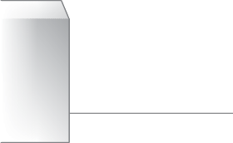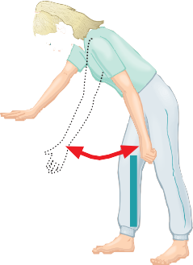

Lying on your back put your arms behind your back and push your elbows down. Hold the stretch for 10 seconds.

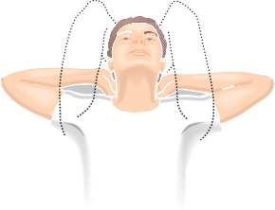

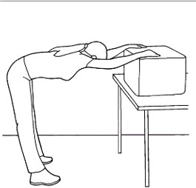Stand with both arms on a table/work top. Lean forward push chest down. Walk away. Hold stretch for 10 seconds.

Production date: June 2025 EP0585