

Whiplash

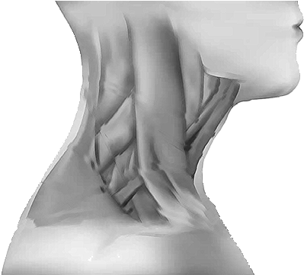

## What is it?

Whiplash is the term used to describe injury shortly after sudden or excessive bending or rotation of the neck.

## How did I get it?

Whiplash is usually associated with car accidents but can also be caused by sports injuries, falls or being struck on the head by a heavy or solid object.

## Signs and symptoms

Symptoms can include headaches, neck pain and stiffness, reduced movement to the neck and upper back and tenderness over the neck muscles. Symptoms can often take six to twelve hours to occur and pain is often worse the next day and for a few days after the injury has occurred. Dizziness, blurred vision, pain in the jaw or pain on swallowing, and unusual sensations of the facial skin

may occur for a short while, but soon go. Tell a doctor if any of these persist. Some people feel irritable, tired and have difficulty concentration for a few days after injury.

## Diagnosis

Whiplash is usually diagnosed from your description of the injury and your symptoms. X-rays would only be taken if a fracture was suspected. Scans and MRIs are rarely used as it is not unusual to have a whiplash injury without any signs of damage to the neck.

## How can I treat it?

The most important thing you can do is to keep moving your neck, every few hours and get back to normal activity as soon as possible. It is noted that, people who carry on with their normal lives and get back to work, recover faster than those who stop their activity levels. Do not wear a neck brace or collar as this will slow down your recovery. Although your neck may be painful it is important to keep it moving, even at the early stages, you will not damage it any further. You can also use painkillers, over the counter or prescribed by your GP. Always check with your pharmacist for the best over the counter analgesia for you.

**Physiotherapy**

Your GP may refer you for physiotherapy. A Physiotherapist will assess your neck and extent of injury and prescribe

a course of treatment involving exercises to increase the strength and mobility of your neck. They can also give you some advice with regard to pain control. They may

mobilise the bones in your neck or work on the soft tissues of your neck, but it will be the exercises provided by your physiotherapist that will aid your recovery the most.

## What happens next?

Whiplash usually gets better on its own or after some basic treatment. Whiplash is not a long term condition and the prognosis is very good.

## What can I do to help myself?

## Moving is good

The spine likes to move. Although it may be stiff after a whiplash injury, movement will help to reduce muscle tension, reduce pain and increase range of movement.

## Painkillers

Muscles do not work as well when they are hurting. Taking painkillers will relieve the pain, enable you to carry out exercise effectively and allow a faster recovery. Always ask your pharmacists’ advice for the best painkillers to take for you.

## Heat and cold

You can reduce your pain by placing a bag of frozen vegetables or ice pack over a damp cloth wherever the pain is for 10 minutes. If you do not like cold packs, you can try heat, a hot water bottle wrapped in a towel or a wheat bag, to relax the muscles of your neck.

## Posture

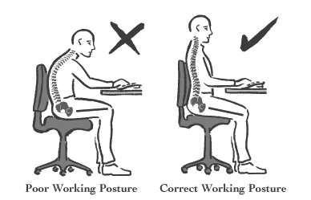Good posture is essential. Check that your sitting position is good, not with your head flexed forward or back rounded.

If you are driving, make sure your shoulders are resting on the seat behind you and you are not leaning forward. Yoga and Pilates may also help with your posture.

## Exercises

These exercises should be carried out often, throughout the day. These exercises may cause discomfort  
but should not increase your pain or symptoms. Perform the exercises in a slow and controlled manner.

## Chin nod in supine

Position yourself in lying with a soft pillow under your head and your knees bent.

Gently nod your head. Gently move back to the start position.

## Head rotation

Position yourself in sitting or standing with a good posture. Gently turn your head

to one side, back to neutral and then to the other side. Try to rotate a little further each time so that you can see over your shoulder.

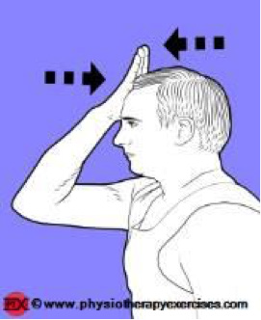

## Isometric neck flexion

Position yourself in sitting or standing. Place one hand on your forehead. Push gently against your hand. Keep your head still and only use approximately 10% effort.

## Isometric neck lateral flexion

Position yourself in sitting or standing with one hand on the side of your head. Gently push your head into your hand. Keep your head still and only use approximately 10% effort.

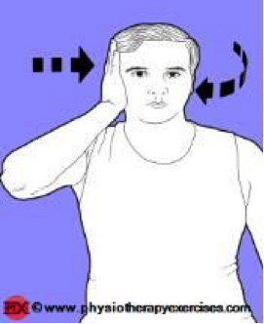

## Isometric neck rotation

Position yourself in sitting or standing. Turn your eyes towards your hand and gently push your head into your

hand while looking over your shoulder. Keep your head still and only use approximately 10% effort. . Ensure that your chin is relaxed and pointing down slightly.

## Neck extension

Position yourself in sitting or standing with a good posture. Gently look up towards the sky and return to the upright position. Ensure that your chin is tucked in prior to carrying out the exercise.

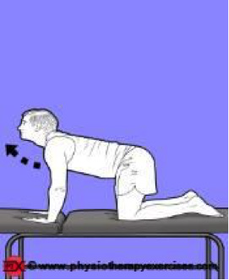**Neck extension in 4-point kneeling**

Position yourself in 4-point kneeling. Ensure that you have your knees under your hips and your hands under your shoulders. Gently draw your belly button towards your spine, push gently through your shoulder blades and lift your head up so that it is level with your shoulders.

Ensure that your chin remains tucked in. Slowly lift your head towards the ceiling. Return to the neutral position. Maintain and hold a safe four point kneeling position while doing the exercise.

## Neck flexion

Position yourself in sitting or standing with a good posture. Gently look down towards your chest and then return to the neutral position.

## Neck flexion and extension in 4-point kneeling

Position yourself in 4-point kneeling. Ensure that you have your knees under your hips and your hands under your shoulders.

Gently draw your belly button towards your spine, push gently through your shoulder

blades and lift your head up so that it is level with your shoulders. Ensure that your chin remains tucked in. Slowly lift your head to look at the ceiling. Return to neutral.

Slowly take your chin towards your chest. Return to the neutral position.

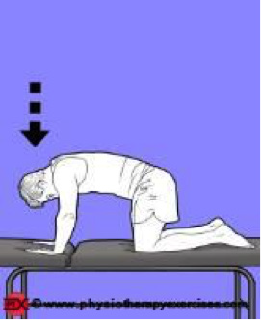**Neck flexion in 4-point kneeling**

Position yourself in 4-point kneeling. Ensure that you have your knees under your hips and your hands under your shoulders. Gently draw your belly button towards your spine, push gently through your shoulder blades and lift your head up so that it is level with your shoulders. Ensure that your chin remains tucked in. Slowly take your chin towards your chest. Return to the neutral position.

## Neck lateral flexion

Position yourself in sitting or standing with a good posture. Centre your neck. Gently bring your ear down towards your shoulder. Return to the centre. You should feel a gentle stretch in the side of your neck.

## Neck retraction in sitting

Position yourself in sitting. Correct your posture. Gently draw your head back by tucking the chin in horizontally while keeping your nose pointing straight ahead.

**Neck rotation in 4-point kneeling**

Position yourself in 4-point kneeling. Ensure that you have your knees under your hips and your hands under your shoulders. Gently draw your belly button towards your spine, push gently through your shoulder blades and lift your head up so that it is level with your shoulders.

Ensure that your chin remains tucked in. Slowly turn your head to look over one shoulder and then the other shoulder. Ensure that your head does not drop down.

Position yourself in sitting. Correct your posture. Gently draw your shoulders up to your ears and down again.

EP0467

Production date: June 2025