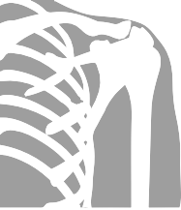

Rotator Cuff disorders

Rotator cuff disorders are one of the most common causes of shoulder pain. There are three frequent conditions that can affect the rotator cuff:

# 1/ Rotator Cuff Tears

**2/ Sub-Acromial Impingement**

**3/ Calcific Tendonopathy**

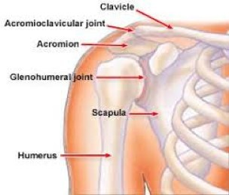**The shoulder joint**

There are three bones in the shoulder region, the collarbone (clavicle), the shoulder blade (scapula) and the upper arm bone (humerus).

There are also a number of muscles, ligaments and tendons around the shoulder. Ligaments are fibres that link bones together at a joint. Tendons are fibres that attach muscle to bone.

# What is the rotator cuff?

The rotator cuff is a group of four muscles that are positioned around the shoulder joint. The muscles are named:

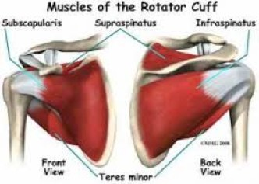

**Supraspinatus, Infraspinatus, Subscapularis and Teres minor**

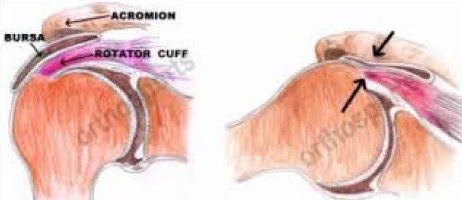The rotator cuff muscles interlock to work as a unit. They help to stabilise the shoulder joint and also help with shoulder joint movement. The four tendons of the rotator cuff muscles join together to form one larger tendon, called the rotator cuff tendon. This tendon attaches to the head of the bony surface at the top of the upper arm bone (the humerus). There is a space underneath the acromion of the scapula, called the sub-acromial space. The rotator cuff tendon passes through here. The sub- acromial

space is filled by the sub-acromial bursa. This is a fluid-filled sac which helps the rotator cuff to move smoothly. It has a large number of pain sensors.

# What are the symptoms of rotator cuff disorders?

* pain and swelling in the front of your shoulder and side of your arm
* pain triggered by raising or lowering your arm
* a clicking sound when raising your arm
* stiffness
* pain that causes you to wake from sleep
* pain when reaching behind your back.

# Rotator cuff tears

The rotator cuff is very vulnerable to being damaged in the subacromial space. This can lead to a tear that is not only painful but also makes the shoulder weak. It can happen suddenly after a single injury or can develop gradually. Rotator cuff tears can be minor/partial or full/ complete depending on the degree of damage to the tendon. Tears to the rotator cuff are very common and may not cause any symptoms at all.

# Subacromial impingement

Also known as tendonitis, bursitis or sub-acromial pain syndrome.

As you lift your arm up, the rotator cuff pushes the top of the humeral head under the acromion. Anything that affects the cuff, such as minor tears or overuse after a period of inactivity, can lead to the humeral head not being pushed down properly. It therefore moves closer to the acromion. This causes pain. It can also happen due to problems with the bone of the acromion. These can include arthritis and bony spurs (protrusions).

# Calcific tendonitis

Calcific tendonitis is the name given when calcium builds up in the rotator cuff tendon. It can cause an increase in pressure in the tendon and chemical irritation. It may be extremely painful. The cause is not known but it can eventually go away without any treatment. It tends to be more common in people between 30 - 60 years of age.

The calcium deposit may affect the way the rotator cuff works causing subacromial impingement.

# What are the treatment options for the rotator cuff disorders?

You should avoid doing anything that aggravates the pain. For example, overhead activities, such as that performed by plasterers or painters and decorators. This may mean that you have to modify or change your work activities. However, do not completely rest your shoulder. Strengthen your shoulder but don’t try to work or play through the pain.

## Pain relief:

* Painkillers such as paracetamol are usually helpful.
* Anti-inflammatories are painkillers too but they also reduce any inflammation and are commonly prescribed. They include Ibuprofen, Diclofenac and Naproxen. Side-effects sometimes occur with anti- inflammatories. Always read the leaflet that comes with the medicine packet for a full list of cautions and possible side-effects.

## Physiotherapy:

* it is really important to keep your shoulder strong and mobile. It is very useful to see a physiotherapist for advice and to be prescribed an exercise programme to do at home if the symptoms aren’t settling quickly.

## Steroid injections:

* these can help to reduce the pain, allowing you to undertake your exercise programme. They may
* reduce the inflammation in the sub-acromial space. Steroid injections can be repeated if the initial response is good.

## Surgery:

* Rotator cuff tears - surgery may be required if the tear followed a sudden injury and when pain and weakness have not improved with steroid injections and physiotherapy.
* Sub-acromial impingement - surgery is rarely required. If necessary an ‘arthroscopic subacromial decompression’ (ASD) can be preformed to increase the amount of space between the acromion and the rotator cuff.
* Calcific tendonitis - ‘ultrasound-guided barbotage’ may be performed. This involves injecting the calcium deposit with salt water and sucking it out through a syringe. The calcium deposit may also be removed by surgery if the pain is extremely severe.

If rotator cuff disorders are adequately treated, there can be complete recovery. This will involve daily exercises to strengthen the shoulder and to keep it strong.

# Exercises For rotator cuff disorders

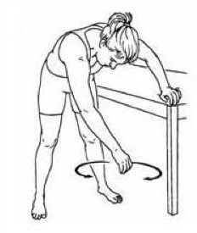The aim of the exercises are to

* 1. maintain your range of movement in your shoulder
  2. strengthen your rotator cuff muscles.

Bend forward 90 degrees at the waist leaning on a table for support. Rock your arm forwards and backwards and round in circles.

Repeat x X day.

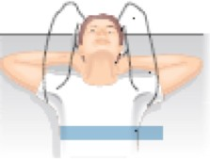Lying on your back on a bed or the floor reach up behind your head as shown. Press elbows backward so that you feel stretch. Hold for 10 seconds repeat 10x.

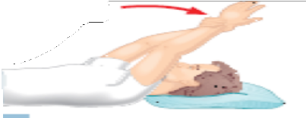Lie on back as shown. Hold bad arm with good arm, palms facing up and raise above head. Hold for 10 seconds repeat 10x.

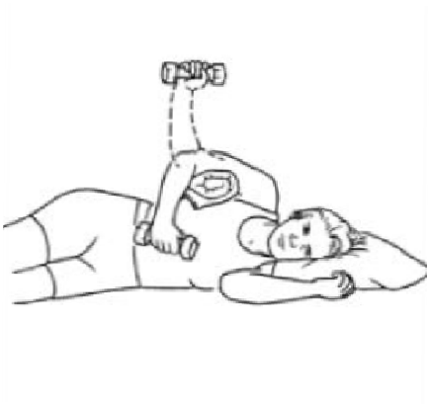

Lying on your good side. Elbows tucked in. Holding a small weight/can lift arm up and out Repeat x x day.

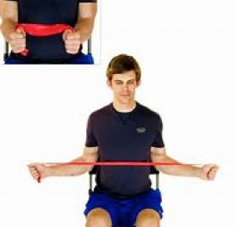

In sitting tuck shoulder blade down and back . Pull band out. Hold 5 secs repeat 10 x 2 x.

EP0643

Production date: June 2025